Medium Speed Management
1. Under ISM, what is a "non-conformity"?

Official log book entries not being completed correctly
A safety officer not being nominated for the vessel
The wearing of non-standard Personal protective equipment
An observed situation where objective evidence indicates the non-fulfilment of a specified requirement

2. Every inflatable liferaft , inflatable lifejacket and hydrostatic release units shall be serviced:
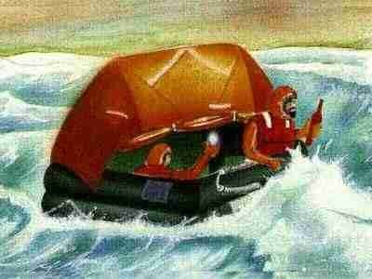
Every 36 months.
Every 18 months.
Every 24 months.
Every 12 months.

3. Once the Safety Management System is verified and working effectively, what document is issued to the ship?

The Document of Compliance
The Safety Management Certificate
The I.S.M. Certificate
The Document of Conformance

4. The pressure delivered by a gear type fuel oil transfer pump suddenly reduces from 5 bar to 4 bar during transfer. From the options given, select the most likely cause of this occurrence.
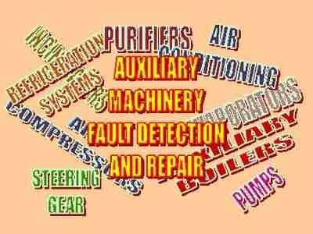
The pump drive has sheared.
The pump gears and casing have become worn.
Part of the pump relief/recirculation valve spring has broken off allowing the valve to open further.
The oil tank from which the oil is being transferred is empty.

5. What is the main precaution to be taken prior to engaging the turning gear for a diesel engine?
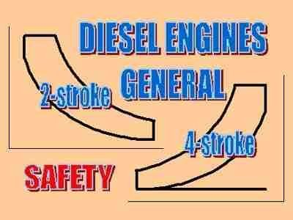
Isolate the starting air supply.
Open the indicator cocks.
Open the crankcase doors.
Transfer main engine control from control room to emergency control console.

6. Which of the options given is the most likely reason for a drop in pressure at the charge air manifold of a diesel engine?
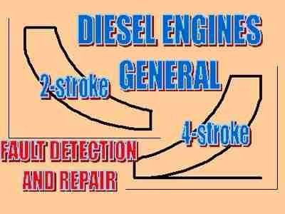
Air passageways or ports to the engine cylinders partly blocked due to fouling.
Air filter to turbocharger fouled or obstructed.
Charge air cooler fouled on waterside
Increased engine load.

7. When planning bunkering operations it is preferable to arrange for the new fuel to be bunkered into empty or nearly empty tanks whenever possible. What is the main reason for this?
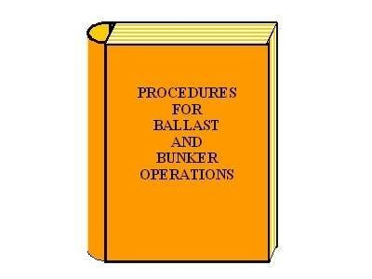
To make it easier to calculate the quantity of fueltaken onboard.
So that the sulphur content of each fuel is known.
To minimise the risk of incompatibility between different fuels.
To minimise the risk of microbial contamination of the fuel.

8. In relation to OPA 90, Which of the following statements is correct?

COTP-zones may have additional rules and regulations
After implementation of OPA-90 there are no area specific rules andregulations
OPA-90 specify rules and regulations for all COTP-zones
OPA-90 specify all oil cargo related rules and regulations

9. A galley hot plate uses a Nichrome / Magnesium Oxide heating element and is to be tested before being put into service for the first time. An insulation resistance test yields a reading of 0.3 M Ohm. Which action should be taken?
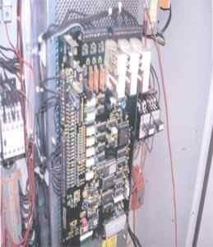
Put the element into service.
Discard the element.
Apply reduced voltage to the element for a few minutes. Then retest and if ok put into service.
Wash the element in a degreasing agent. Then retest and if ok put it into service.

10. What would be a typical setting for the overspeed trip to operate and shut down the engine on a medium speed diesel engine?
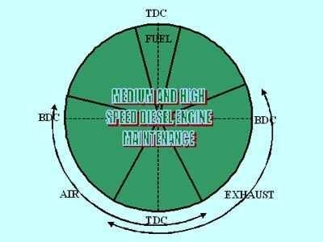
25% above engine rated speed
15% above engine rated speed
5% above engine rated speed
1% above engine rated speed

11. How long after starting a refrigeration compressor should the oil separator return valve be opened?

It should be opened once the oil separator unit has warmed up.
It should be opened only when the crankcase oil level is low.
It should be opened one minute after start up.
It should be opened before start up.

12. A refrigeration plant is short cycling even though there is plenty of refrigerant in the system and all of the rooms are above temperature. From the options give select the one which is the most likely cause of the problem?

Insufficient cooling water flow through the condenser causing the automatic high pressure cut out to operate.
Blocked filter drier causing the automatic low pressure cut out to operate.
Ice formation in the meat room evaporator coil causing the automatic low pressure cut out to operate.
Low oil level in the sump causing the automatic low oil pressure cut out to operate.

13. In a distress situation and immediately after the distress signal has been sounded, what is the next action to be taken by the Chief Officer on duty?
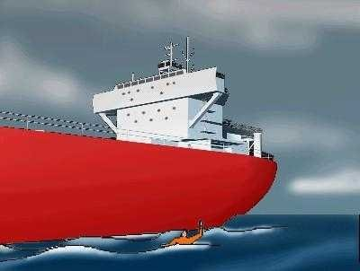
Call the nearest coastal radio station
Use the VHF-radio telephone to ask ships in the vicinity to stand by
Send distress signals to call for help
Use the intercom to inform crew and passengers of the reason for the alarm

14. Which two persons check the Declaration of Security? Select the correct pairing.
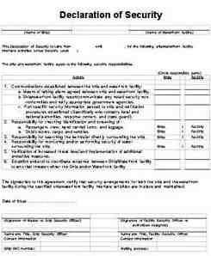
The Company Security Officer and the Port Facility Security Officer
The Local Coast Guard Officer and the Port Facility Security Officer
The Company Security Officer and the Ship Security Officer
The Port Facility Security Officer and the Ship Security Officer

15. A fluorescent lamp is found to be flicking rapidly. What is the possible cause?
Loss of active material or fracture at one electrode
Arc suppresser contacts are shortened
Normal ageing of lamp
Short-circuit on light fitting

16. Select, from the options given, the one most likely to result in a sudden reduction in main diesel engine operating speed during normal operation.
Leaking exhaust valves.
Bad fuel oil quality.
Fuel oil pipes or filters becoming fouled.
Loss of signal to engine governor.

17. How can a lead-acid type battery be checked to confirm if it is fully charged or not?
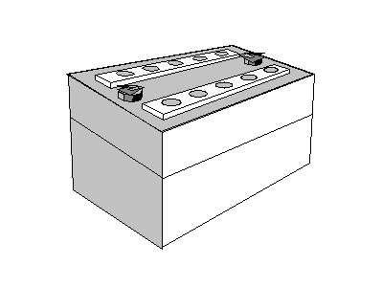
Measure the relative density (specific gravity) of the electrolyte
Measure the level of the electrolyte
Measure the battery voltage
Measure the temperature of the electrolyte

18. The emergency fire pump is in accordance with good seamanship and precautionary routines run and tested weekly. Routine checks and maintenance are normally carried out by dedicated personnel. To ensure safe and appropriate operation of the pump, would you consider it beneficial that the same dedicated personnel operate the pump in emergencies?
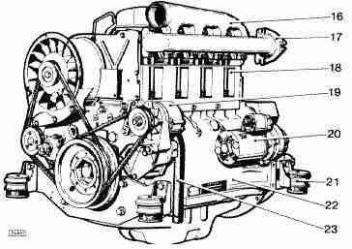
Only senior engineers should operate the emergency pump.
Only senior deck officers should operate the emergency pump.
To ensure safe operation of the emergency pump,only dedicated personnel must be permitted to operate the pump.
In case of accidents, it is important that a wide range of personnel must be permitted and trained to operate the pump.

19. An actuator has "loose linkage" with the valve stem. What is the result output from controller to identify the problem?
Linear curve
Compound curve
Process Cycling
Step curve

20. When there is a need to interrupt current flow in a high voltage system it may be very difficult to quench the electrical arc which is generated at the circuit breaker contacts. Which of the following arcing media is commonly found in high voltage marine switchgear?
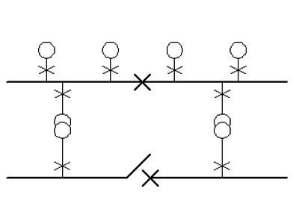
Vacuum
Oil
Air
Water

21. During inspection of the cylinder cover from a medium speed diesel engine cylinder it is noted that cracks have occurred between the two exhaust valve pockets and the fuel injector pocket. Select from the given options the most probable cause of this type of failure.
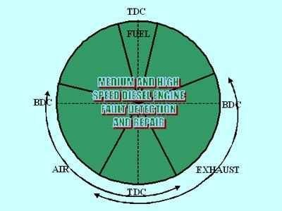
Fuel impingement on the cover due to distorted injector nozzle holes.
Excessive tightening of the fuel injector in the pocket.
Excessive maximum pressure in the cylinder due to engine overload.
Excessive thermal stress due to insufficient cooling of the cylinder cover.

22. Two identical medium speed engines are connected through clutches and a reduction gearbox to a single controllable pitch propeller. It is noted during normal operation that the load sharing between the engines is uneven with one engine taking a greater proportion of the load as the total load increases even though they are equally loaded at low load. Select from the options given the most likely cause of this problem.
One of the engines is running faster than the other at high loads.
The clutch on one engine is slipping.
The fuel filters in the supply line for one of the engines are blocked
The governor droop settings are incorrectly set and are not matched.

23. One of the Main Engine cooling pumps is down for maintenance. The rest of the cooling pumps are operating near full capacity with minimum margins on the maximum temperature limit. What should be the correct action to take with regard to UMS operation?

Hope that the alarm function and automatic temperature regulation will function correctly and switch to UMS-mode as normal
Arrange with a rating "on watch" in the engine room for the UMS period.
Operate the engine room on manual mode until the maintenance is completed and the cooling pump is operational and switched to stand-by mode.
Arrange frequent checks of the condition during the night otherwise operate in normal UMS-mode

24. What is the purpose of the air distributor in a diesel engine air start system?
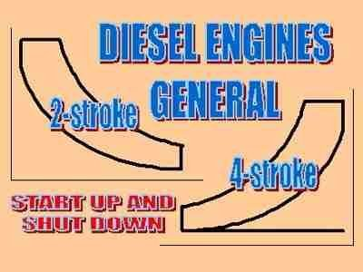
To ensure the air consumption from each of the main air receivers is equally distributed.
To ensure the cylinder air start valves operate in the correct sequence and for the correct period.
To ensure that the automatic valve in the air start system opens and closes at the correct time.
To ensure that the start air is distributed equally to the each of the engine cylinders.

25. A heat exchanger of the tube and shell type is used for cooling lubricating oil with seawater as the secondary fluid. Which of the options would indicate that the tube stack was becoming fouled (scaled or coked) rather than blocked?
An increase in the temperature difference between the seawater inlet and outlet and a reduced temperature difference between the lubricating oil inlet and outlet.
A reduced temperature difference between the seawater inlet and outlet and an increase in the temperature difference between the lubricating oil inlet and outlet.
An increased temperature difference between the seawater inlet and outlet and also between the lubricating oil inlet and outlet.
A reduced temperature difference between the seawater inlet and outlet and also between the lubricating oil inlet and outlet.

26. In an automatic temperature control system, operating with a PID controller, which of the following settings or parameter adjustments may result in system oscillation?
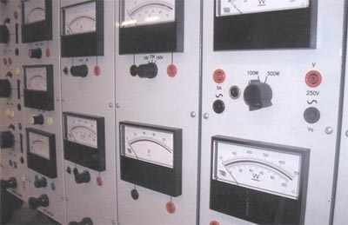
Gain too low
Temperature change
Gain too high
Too short D-time

27. You have to choose one of the following instruments for measuring pressure in an air bottle in measuring range 0 - 35 BAR. Which instrument would you install?
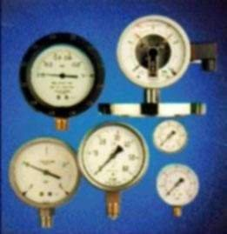
Bourdon Tube manometer
Bellow type manometer
U-type H2O manometer
U-type Hg manometer

28. Is there any special area under MARPOL where it is forbidden to pump out any sludge or oil residues?

There are special areas where it is forbidden to pump out any sludge or oil residues
There isn't any special area where it is forbidden to pump out any sludge or oil residues
There are 4 special areas: the Baltic Sea, Mediterranean Sea, Red Sea and Black Sea where it is forbidden to pump out any sludge or oil residues
There are 3 special areas: the Baltic Sea, Mediterranean Sea, and Black Sea where it is forbidden to pump out any sludge or oil residues

29. A 5V dc source has an internal impedance of 0.2 ohms. When a load of 2.3 ohms is applied what voltage will be measured at the source terminals?
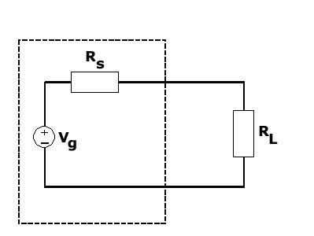
5.0 V
5.2 V
4.8 V
4.6 V

30. During inspection of a medium speed diesel engine piston of the composite type it is found that the steel crown is loose at its connection to the alloy skirt. Further inspection reveals damage to the surfaces and evidence of metal particles where the two parts are connected. Select, from the options given, the likely cause of this type of damage.
Fatigue due to excess compression at the joint between the components.
Fretting due to loss of compression at the joint between the components.
Shear of the metal surfaces due to excessive load on the engine.
Crushing due to over tightening of the piston crown retaining bolts.

31. Which of the following terms is used to describe a thermodynamic process in which no heat transfer into or out of the system occurs?
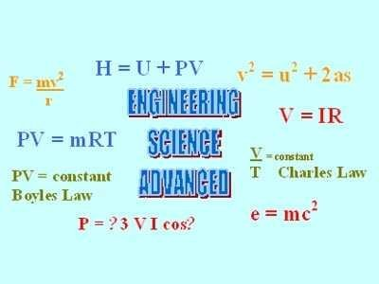
Isochoric.
Polytropic.
Isothermal
Adiabatic.

32. *The correct order of actions to be taken in a fire emergency, should be...
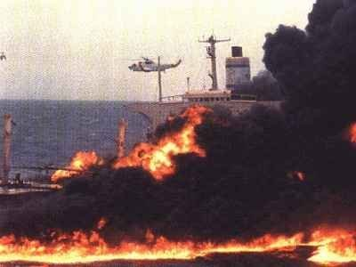
Evaluation of the situation, confinement of fire, rescue and life-saving, extinction
Evaluation of the situation, rescue and life-saving, confinement of fire, extinction, then feed back on the emergency
Extinction, confinement of fire, feed back on the emergency, rescue and life-saving, then evaluation of the situation
Extinction, evaluation of the situation, confinement of fire, rescue and life-saving

33. For how long is the health certificate valid for a seafarer above the age of 18?
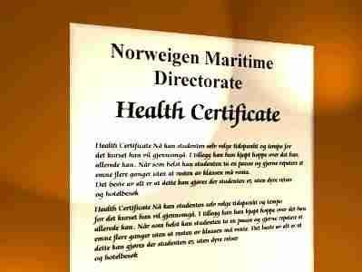
Three months.
One year.
Two years.
No time limit.

34. In the diagram below we want to verify the resistance of the PT100 sensor fitted with compensation. What is the correct calculation?
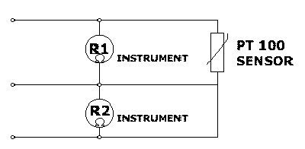
R(Pt100) = R1 - R2
R(Pt100) = R1 x R2
R(Pt100) = R1 : R2
R(Pt100) = R1 + R2

35. Power is available at a three-phase motor starter but nothing happens (at starter or motor) when the start button is operated. Which of the following is a likely cause?
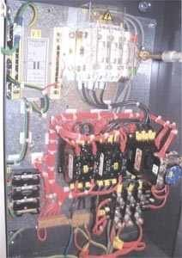
Faulty contactor coil
Open circuit in one of motor cables
Faulty overcurrent relay
Motor cable undersized

36. What type of dynamic forces may cause indent in plating on forecastle deck and main deck in way of pillars inside forecastle?

Pressure forces caused by green water on deck
Forces created by waves on the forecastle
Slamming in way of flat bottom forward of light draught
Impact pressure forces in way of abrupt or flared bow

37. Prior to bunkering operations it is necessary to check the quantity of fuel remaining onboard and that there is sufficient room for the fuel that is to be loaded. What is the best method to use to establish this?
Take a full set of readings from remote content gauges.
Do a complete sounding of all fuel bunker tanks
Use the latest figures from the fuel record book.
Sound the tanks which you think might still contain some fuel.

38. The majority of marine diesel engines operate with either a pulse or a constant pressure turbocharging system. What is the main difference between these two systems?
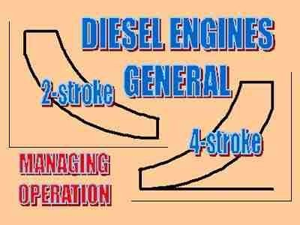
Constant pressure systems have all engine cylinder exhausts connected to a common large exhaust gas manifold.
Constant pressure systems only ever have a single turbocharger irrespective of the number of cylinders on the engine.
Pulse systems have all of the cylinder exhausts connected to a common large exhaust gas manifold
Pulse systems always have a turbocharger for each group of three cylinders.

39. A positive displacement, rotary type, volumetric flow meter reads low with an error reading of 1% when used to measure flow of heavy oil and 2.5% when used to measure the flow of diesel oil. From the options given select the most likely cause of this difference in error?

The low lubricity of the diesel oil is increasing the friction in the rotating element and slowing the rotor down.
The meter is worn internally.
The lower mass of diesel oil results in a lower reading.
The higher viscosity of the heavy oil is slowing down the rotary element in the meter.

40. MARPOL - Annex IV. Your ship has in operation an approved sewage treatment plant certified by the Administration. During discharge, while vessel is awaiting pilot off Cape Henry, USA, the surrounding water is discoloured. What kind of action would be appropriate to take?
Stop discharge.
Continue discharge since Annex IV of MARPOL is internationally not yet in force.
Continue discharge since the treatment plant is of an approved type.
Reduce discharge rate in order to have less discolouration of surrounding water.

41. When starting three phase induction motors which of the following starting methods will immediately apply rated voltage to the machine?
Direct on Line
Soft starter
Star Delta
Auto – transformer

42. During maintenance work on the main engine a problem arises regarding the lifting of a main component in that the manufacturer's instructions ado not apply to the engine as fitted and present a hazard. In which of the information/record sources given in the options, is it most important to record the information relating to this anomaly?

Engine room planned maintenance schedule.
Safety officers report.
Engine room log book.
ISM procedures in the ship's safety manual.

43. The picture shows a liquid filled thermometer. Liquid filled thermometers and manometers are often installed onboard ships. What is the main purpose for the liquid filling of such pointer instruments?
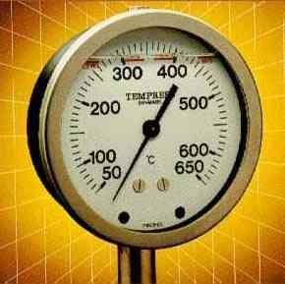
Keep the rear side of the front glass clean
Reduce mechanical wear on the internal parts caused by vibration
Avoid water penetration from outside
Compensating for changes in ambient temperature

44. Who is responsible for maintaining the vessel's structural strength?

The flag state administration.
The classification society.
The master.
The management company.

45. Continuity testing of a delta connected three phase induction motor yields the following results; U1-V1 = 4 ohms, V1-W1 = 4 ohms, W1-U1 = 4 ohms. What is the value of continuity resistance for each winding ie. U1 - U2?
6 ohms
12 ohms
4 ohms
2 ohms

46. A vessel which normally operates with the engine room in UMS mode is unable to do so because of defects to some of the critical alarm functions. What are the main considerations that the Chief Engineer must take into account when planning alternative arrangements to cover the engine room requirements until the defects are cleared?
A work rota is established to ensure full coverage of engine room watchkeeping duties and adequate rest periods for the engineering staff.
A work rota is established to ensure that the necessary repairs can be carried out as soon as possible.
A work rota is established to ensure that normal routine maintenance is carried out on time in accordance with the planned maintenance schedule.
A work rota is established to ensure at least one person is in the engine room at all times while the defects exist.

47. A combustible gas indicator of the catalytic filament type is used to check the atmosphere in an enclosed space onboard ship. When taking readings in a fuel tank which has been emptied for cleaning the meter reading initially rises and then falls back to zero. What is the likely defect, if any, in the instrument when this type of behaviour is displayed?
The batteries are flat.
The filament is contaminated due to too high a concentration of hydrocarbons.
The sampling pump is faulty.
The filament has burnt out.

48. When checking the cylinder pressures of a 6 cylinder medium speed diesel engine it is found that one of the cylinders has a high maximum pressure. What is the most likely cause of this?
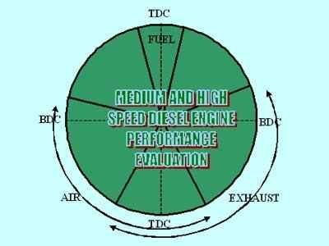
Fuel pressure to the engine is too high.
Fuel timing to that cylinder too far retarded.
Fuel timing to that cylinder too far advanced.
Exhaust valve on the cylinder with the high pressure is leaking.

49. Which of following are security duties?
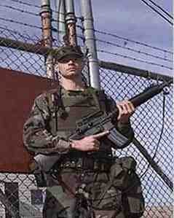
Checking ID of visitors onboard
All alternatives
Monitoring of restricted areas
Calibration of security equipment

50. After a couple of hours of operation the failure alarm sounds for a heavy fuel oil purifier which is operating on a timed automatic sludge cycle. Upon investigation the purifier is found to be running slowly and when opened up the casing and sludge outlet is heavily fouled with sludge in contact with the bowl. From the options given what is the most likely cause of this problem?
The heavy fuel is unstable leading to excessive high viscosity sludge formation.
The clutch for the drive shaft is worn and slipping.
The purifier bowl has not closed properly.
The dirty oil throughput is excessive.

51. One cylinder of a diesel engine is operating with a high exhaust gas temperature. From the options given, select the one most likely to cause this condition.
The charge air is delivered to the engine at too high a temperature.
Water leakage into the cylinder.
Cylinder lubricating oil supply rate to the engine is excessive.
Fuel injection valve opening pressure is too low.

52. A medium speed diesel engine, operating on heavy oil has suffered repeated exhaust valve failure. Upon inspection damage is noted on the underside of the valve resulting in some cases in holes passing through the valve even though the seating face appears hardly damaged. Which of the given options is the most likely cause of this type of damage?
High temperature corrosion due to high vanadium content in the fuel oil.
Incorrect tappet (rocker arm) clearance preventing the valves from closing properly.
Cold temperature corrosion due to high sulphur content in the fuel and incorrect grade of cylinder lubricating oil.
Failure of the valve rotators causing distortion of the valve seat.

53. When starting air is applied to a diesel engine the engine fails to turn over but is seen to oscillate back and forth. What is the most likely cause of this problem?
An interlock is blocking the air to the starting air distributor.
The automatic valve has failed to open.
Starting air pressure is too low.
One or more cylinder air start valves are stuck open..

54. A medium speed diesel engine is used to drive a controllable pitch propeller through a suitable clutch and reduction gearbox. What should the propeller blade attitude normally be after the engine is started and before the clutch can be engaged?
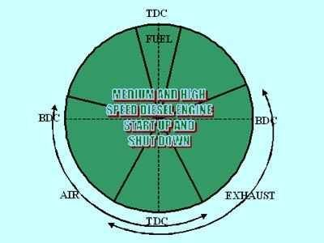
The blades should be in the zero pitch position.
The blades should be in 20% pitch position.
The blades should be in the full ahead position.
The blades should be in the full astern position.

55. How should the spare oxygen and acetylene gas welding bottles be stored onboard the ship?
In the workshop in the engine room as close as possible to welding equipment.
In two separate rooms outside the engine room space.
In a refrigerated room.
In the steering flat.

56. As a minimum, how often shall life boats be launched with their assigned operating crew aboard and manoeuvred in the water according to SOLAS?
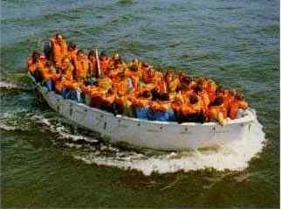
Every two weeks.
Every month.
Every three months.
Every week.

57. The overspeed shutdown is to be tested on a high speed four stroke diesel engine driving through a pneumatic clutch. The overspeed protection is provided by a solenoid operated dump valve in the governor servo system activated by an electrical signal from a small synchro motor. What is the preferred method of testing such a shutdown?
Use a crowbar to lever the governor linkage to full fuel with the clutch disengaged and engine off load.
With the engine off load manually increase the governor speed setting until the shutdown operates, reduce the shutdown set point if necessary.
With the engine on a high or full load suddenly disengage the clutch.
Reduce the set point so the shutdown operates at normal engine speed.

58. A hand flare must have a burning period of at least
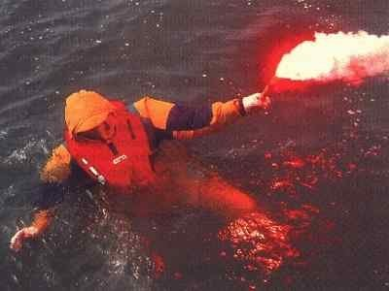
30 Sec
1 Min
10 Min
5 Min

59. The machinery detail plate is missing from a large electric motor and the weight is unknown. As part of a routine maintenance check the motor has to be lifted to access some other equipment. Which of the given options is the correct action that should be taken?
Try and lift it with the engine room crane as it is designed to lift the heaviest components in the engine.
Use the biggest chain blocks and strops available and carry out a trial lift.
Estimate the weight of the motor and select a chain block and strop with a safe working load of 1.5 times the calculated load.
As it is only a routine maintenance and not a breakdown then postpone the task until full details of the motor can be obtained.

60. Which ideal heat engine cycle is the vapour-compression refrigeration system based on?
The reversed Carnot cycle.
The Dual cycle
The Otto cycle.
The Rankine cycle.

61. How can the pressure be regulated during start up of a positive displacement pump such as a gear pump?
Positive displacement pumps operate at constant pressure and cannot be regulated.
Adjustment of the pressure relief valve to recirculate part of the flow.
By throttling the discharge valve
By throttling the suction valve.

62. The majority of convensions adopted under the auspices of IMO fall into which of the three main categories:

Maritime Safety, STCW, Maritime Security
Safety, Terrorism, ILO
There are no conentions that fall under IMO
Maritime Safety, Prevention of Marine pollution, Liability and compensation

63. The bottom end bolts employed in 4 stroke diesel engines are usually given a finite life and must be replaced periodically. What would be the normal failure mode that would affect these bolts if they were not replaced as required?
Failure due to torsional stresses
Failure due to bending stresses
Failure due to tensile stresses
Failure due to fatigue stresses

64. The pressure control of a vessel's domestic water system, which includes a hydrophore tank pressurised by air, is achieved by stop/start of the fresh water pumps using pressure switches. How should the system be prepared for first use to give correct operation of the pressure control?

Fill the hydrophore tank completely with water and then pressurise with air up to the pump cut out point.
Fill the hydrophore tank up with freshwater allowing it to compress the air already in the tank and then adjust the pump cut out to match the pressure in the tank when it is almost full.
Fill the hydrophore tank to approximately 75% full with water and then pressurise with air up to the pump cut out point.
Pressurise the hydrophore tank with air to approximately 50% of the pump cut out pressure and then allow the pump to fill the tank until it cuts out.

65. A 2 term controller is used to control the fuel oil temperature for a thermal oil system used for heating services. The control is very unstable with the measured value hunting constantly. Select the most probable cause of this problem from the options given.
Integral action reset time is set too fast.
Proportional band width is set too narrow.
Proportional band width is set too wide.
Integral action reset time is set too slow.

66. Hand flares and buoyant smoke signals can continue to burn or emit smoke after having been immersed for a period of 10s
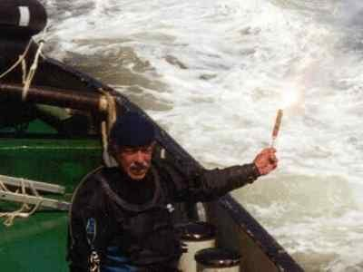
Right if the immersion depth is smaller than 100 mm
Right
Wrong
Right if the immersion depth is more than 1m

67. These circuits are all active filters. Which of the circuits is a low-pass filter?
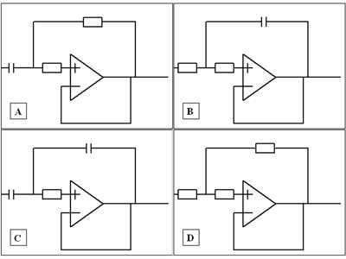
Figure A
Figure D
Figure C
Figure B

68. Spray painting has been carried out in the engine room while the engine was running, and the turbocharger intake filter was not protected. Which one of the options given is most likely to result from this?
Scavenge air pressure lower than normal.
Scavenging air pressure is higher than normal
Exhaust gas temperatures lower than normal.
The revolution of the turbocharger lower than normal.

69. Some ships generate electrical power at 440 Volts, but then step up this voltage to supply specific electrical equipment. One common example, may be to feed a large bow thruster. Why is this done?
The overall ship's electrical load does not justify High Voltage generating plant. This method allows more power to be delivered to the bow thruster at low running cost.
A large bow thruster will draw very large currents at low voltage. Being typically remote from the generator, significant voltage drops would occur at low voltage.
Manufacturers can supply High Voltage bow thrusters at less cost, and the power factor is improved.
The shipyard could not purchase High Voltage generating plant at the time of manufacture, so they used what was available at the time.

70. What is the normal slow down/shutdown temperature for the jacket cooling water outlet from a diesel engine cylinder?
95 - 98° C
85 - 88° C
75 - 78° C
105 - 108° C

71. For a 4-stroke diesel engine, the exhaust gas from the funnel is seen to be white/light grey in colour. Which of the options given is the most likely cause of this.
The engine is burning lubrication oil.
Water leaking into the combustion chamber.
Faulty fuel injection valve.
The engine is overloaded.

72. The torsion meter for the main propeller shaft is reading high. The torque is sensed using the angle of twist principle with two clamp rings attached to the shaft at a fixed distance, with stationary proximity switches for measuring the angle of twist and also shaft speed fixed to a rigid stool. What is the most likely cause of the high reading?
Circumferential slip of the after clamp ring in the opposite direction to shaft rotation.
Circumferential slip of the forward clamp ring in the opposite direction to shaft rotation.
Axial slip of one of the clamp rings to bring them closer together.
Axial slip of one of the clamp rings to move them further apart.

73. What type of generation and distribution system is used for high voltage system?
Single phase, 2-wire neutral earthed
3 phase, 4-wire insulated
3 phase, 3-wire neutral earthed
3 phase, 3-wire insulated

74. A mechanical-hydraulic speed control governor fitted to an auxiliary engine is giving erratic speed control causing the engine to hunt wildly even when there is only a small load change. From the options given which is the most likely cause of this condition?
Compensation needle valve is open too much.
Speed droop setting set too low.
Speed droop setting set too high.
Compensation needle valve is not open enough.

75. Which cell voltage is required to trickle charge a lead acid battery?
2.5 V
2.0 V
2.15 V
1.2 V

76. A medium speed diesel engine, operating with a pulse turbocharging system, has been adjusted to have good power balance. What would the cylinder exhaust gas temperatures, relative to each other, be expected to be?
plus or minus 5 degrees Celsius.
plus or minus 30 degrees Celsius.
All cylinder exhaust temperatures should be equal if the cylinder power balance is correct.
plus or minus 70 degrees Celsius.

77. In the type of fluorescent lamp system shown in the illustration, which of the following indicates the purpose of the starter?
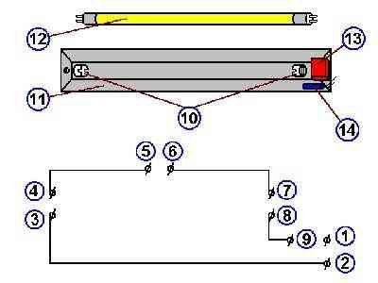
To switch on current through the lamp, and to disconnect the ballast once the lamp has started..
To pass current through the lamp heaters, and then interrupt the inductive striking current.
To create a high starting current.
To charge the ballast to a high inductive current, and then divert this current through the lamp.

78. How often shall crew members participate in fire drills?

Once every week
Once every year
Once every 6 months
Once every month

79. The temperature control for the central cooling system low temperature circuit has failed and a new 3 term controller is to be fitted. Which of the given options would be the correct method of setting up the controller?
Set the derivative action first.
Set the integral action first.
All three actions should be set simultaneously.
Set the proportional action first.

80. Medium and high speed diesel engines used for marine propulsion normally require a reduction gearbox to be fitted in order to achieve suitable output speeds for the propeller. What device is normally required in the drive arrangement in order to avoid damage to the gearing due the torque variations of the diesel engine output?
A moment compensator.
A flywheel.
A mechanical friction clutch.
A flexible coupling.

81. This figure shows a transformer, with two windings, N(1) = 2000 and N(2) = 1000 turns, on a common magnetic circuit. Assume that there is no energy loss in the transformer itself. Calculate the current I(2) when the current I(1) = 2 A.
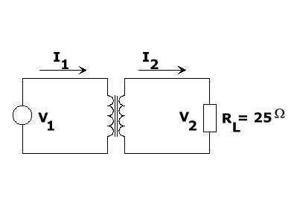
I(2) = 4 A
I(2) = 2 A
I(2) = 1 A
I(2) = 8 A

82. When temperature of a liquid is higher than normal temperature, what happens to the viscosity?
Initial decrease before returning to original viscosity
Viscosity increases
No change in viscosity
Viscosity decreases

83. Which of the following conditions will block the starting signal for the air start system of a medium speed diesel engine which is being used for main propulsion purposes?
Clutch engaged.
Low jacket cooling water temperature.
Valve rotators not operating.
Low start air pressure alarm.

84. What principle of measurement are viscosity controllers usually based on?

measurement of flow
Measurement of differential pressure
measurement of temperature
measurement of two different temperatures

85. Why is it necessary to have an effective ballast water management plan which includes provision for changing out ballast in open water rather than discharging ballast in coastal waters?
To avoid the introduction of non-indigenous species of marine life from one area to another.
To keep the ballast water fresh in the ballast tanks during long voyages.
To allow ballast tank inspections to be carried out during ballast passage.
To ensure that ballast tanks are always pressed up during a ballast voyage to avoid free surface effects.

86. What would the results of a TAN test, carried out on lubricating oil samples from a diesel engine, indicate?
A measure of the organic acids in the lubricating oil.
A measure of the remaining alkalinity in the lubricating oil.
A measure of the inorganic acids in the lubricating oil.
A measure of the of organic and inorganic acids in the lubricating oil.

87. A medium speed diesel engine which is supported on a steel chocking system has had repeated problems with two of the chocks at the end of the engine on the port side becoming slack. This has led to some fretting damage to the bedplate and tank top in that area. What action should be taken to affect a cost effective permanent repair?
Replace the complete steel chocking system with a resin based system.
Replace the damaged chocks with resin based chocks of an appropriate size.
Tighten the holding down bolts in that area to 150% recommended load to prevent further slackening and fretting.
Replace the complete steel chocking system with one using resilient mounts to accommodate movement and avoid further incidents of fretting.

88. Check the items that can be a possible threat

Cargo tampering and Stowaways
All alternatives
Bombing and Sabotage
"Piracy, Hijacking and Smuggling"

89. What is the bias value used for in a controller?
It is used to remove steady state error at a reference set point
It is used to adjust a controller's proportional response to error
It is used to speed up control response in slow process, vice versa
It is used to remove all error accumulated over time

90. Shortly after starting up a fuel oil purifier oil is seen to be trickling out of the sludge outlet. Which of the options given is the most likely cause of this problem?
Damaged bowl seal.
Excessive back pressure in the clean oil outlet.
Insufficient seal water supplied during start up.
Incorrect gravity disc fitted.

91. The diagram shows a thyristor (SCR) with a Resistor and Capacitor (R and C). Which of the following applications is the RC network performing?
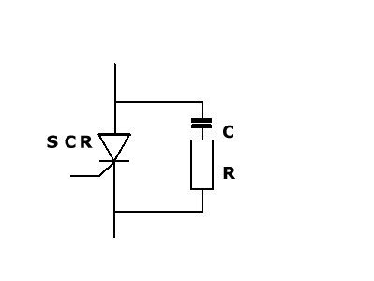
Divert fast voltage spikes which may lead to uncontrolled switch on.
Allow bypass route for ac signals.
Provide voltage smoothing for SCR power supply.
Assist SCR switch on.

92. The instrument air system is suffering from excess water carry over to the instrument air lines. The air intake to the compressor has very high humidity. Which of the actions given in the options will most likely result in reducing this problem?
Increase the cooling water flow through the compressor intercooler and aftercooler.
Reduce the superheat setting on the instrument air refrigeration/dryer unit.
Use an additional coalescer filter in the inlet to the instrument air filter system.
Shorten the time between automatic receiver drain blow downs.

93. A viscosity controller for the main diesel engine fuel oil supply is giving poor control resulting in the viscosity of the fuel oil being too low at the engine. Which of the defects given in the options is likely to be the cause of this problem?
The drive for the internal sample pump for the viscometer has sheared.
The bellows in the DP cell is ruptured giving no differential pressure signal.
Capillary tube in the viscometer is blocked giving high differential pressure at the DP cell.
The air supply pressure to the controller for controlling the steam valve for steam to the fuel heater is too low.

94. Which of the following requirements regarding life-buoys correspond to present regulations? (SOLAS III/7.1)

Not less than half the total number of lifebuoys shall be provided with self-ignighting lights
At least four life-buoys on each side of the ship shall be fitted with buoyant lifelines
At least one lifebuoy with self-activating smoke shall be placed within the vicinity of the stern
All the life-buoys shall be placed in holders with quick-release arrangement

95. What do you understand by the term "Risk Assessment", and how would this be carried out on board?
States than when work has a degree of risk that the work is not carried out
Requires a great deal of preparation and involves recording everything on paper
Identify the hazards, quantify the risks, put control measures in place, monitor the work activity and review
Identify the hazards and specify the personal protective equipment that would be required to complete the work

96. The image shows an indicator diagram taken from a diesel engine cylinder. Which of the following options is the action most likely to identify the fault.?
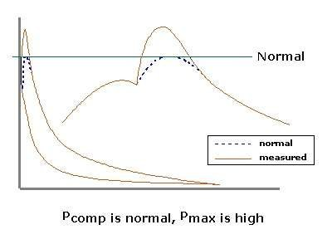
Check if the fuel pump injection is too early, or fuel pump lead is too great, for that cylinder.
Check the exhaust valve.
Check if the fuel injection valve is partly blocked.
Check that the fuel temperature and viscosity are correct.

97. Marine diesel engines are normally provided with automatic protection devices which operate in the event of abnormal conditions arising. Why would medium speed engines used for main propulsion normally only automatically slow down for certain abnormal conditions but automatically shut down for the same conditions when used to drive an alternator?
Sudden total loss of propulsive power may seriously endanger the vessel. This is a greater risk than engine damage.
The gearbox and clutch of the propulsion system may be damaged if the engine suddenly stopped.
The vessel could continue to operate and manoeuvre without any electrical power at all as long as the main engine is still running.
Since the engine used for propulsion would usually be bigger the sudden stop would generate greater thermal stress which may damage the engine.

98. This is a typical emitter follower. What is the main reason for use of an emitter follower?
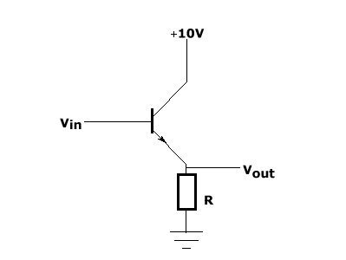
The input impedance is made much larger than the output impedance
The collector can be connected to as high voltage as 10 V DC
The V out is always equivalent to the V in
The input impedance is made much smaller than the output impedance

99. A Cargo Ship Equipment Certificate will be issued for:

4 years
5 years with control every 12 months
2 years with control every 6 months
3 years

100. A transformer, rated at 22 kVA, 440/220 Volts, 60 Hz, is used to step down the voltage for a lighting system. The low tension voltage is to be kept constant at 220 Volts. What load impedance connected to the low-tension side will cause the transformer to be fully loaded?

2.2 Ohms
22 Ohms
220 Ohms
0.22 Ohms

101. The main engine is running steady with an average exhaust gas temperature of approximately 350° C. What would be a typical alarml/slow down setting for the cylinder exhaust gas temperature deviation from the average?
+/- 30° C
+/- 50° C
+/- 10° C
+/- 80° C

102. How will continuous low load operation influence the time between overhauls, tbo, for the cylinder covers and associated valves of a 4-stroke diesel engine?
Increase the time between overhauls since the engine is not working as hard.
No influence at all, the required overhauls are unaffected by operating load.
Increase the time between overhauls since fuel injectors work better at low load so combustion will be improved and the maintenance will be reduced.
Reduce the time between overhauls due to increased fouling.

103. Some fuel oil and lubricating oil separators have a facility to control the back pressure of the clean oil outlet during start up and operation. What is the purpose of this control function?
To control the amount of fuel passing through the separator.
To assist in discharging the bowl contents during the sludge cycle.
To help to maintain the oil/water interface at the correct position.
To reduce the amount of sealing water required during operation.

104. Which of the following options would be a typical differential pressure setting for a main engine slow down in the event of jacket cooling water system low flow?
0.2 to 0.5 bar
1 to 2 bar.
5 Bar
10 Bar

105. The HP discharge valves of a 2 stage air compressor suffer from build up of carbon deposits even though the correct maintenance is carried out on them. What is the most likely cause of this problem?
Worn scraper and piston rings.
Compressor cooling water temperature too low.
Water in the compressor lubricating oil.
Ineffective air intake filter.

106. The fuel consumption for the main diesel engine has gradually increased over a period of a few months. All system pressures and temperatures appear normal. From the options given, choose the one which is the most likely cause of this.
Sea water temperature changing.
Damaged propeller blade.
Water in the fuel.
Fouling of the hull

107. For which ships is the SOLAS convention applicable?

For passenger vessels only.
For all vessels.
For all vessels except passenger vessels.
For tankers and other vessels carrying persistent oil as cargo.

108. This circuit consists of a voltage source V, a change-over switch S, a resistor R and a capacitor C. The voltage/time figures 1 to 4 show changes in the voltage V(C) when the switch S is suddenly shifted from position 1 to 2 at time t = 0. Only one of the diagrams is correct. Which?
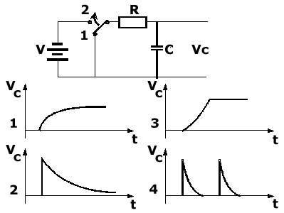
Figure 3
Figure 2
Figure 1
Figure 4

109. Peak pressures and exhaust temperatures taken from a high speed diesel engine shown an unacceptable variation between cylinders. Compression pressures for the cylinders are approximately even. High pressure fuel is supplied to the fuel injection valves by an inline monobloc pump. From the options given which is the most likely defect to cause this problem?
The drive coupling to the inline monobloc fuel injection pump is incorrectly aligned.
The fuel pump elements in the inline monobloc fuel injection pump are unevenly worn.
The hp fuel pipes from the inline monobloc fuel injection pump are partly and unevenly choked.
The inline monobloc fuel injection pump is incorrectly calibrated and metered.

110. When performing electrical testing of a three phase motor, insulation resistance measurements may be influenced by which of the following?
Humidity, frequency and dampness
Humidity, pressure and surface contamination
Temperature, humidity and surface contamination
Temperature, pressure and dampness

111. For some time the remote reading temperature gauge for the meat room has been reading a higher temperature than the local liquid in glass thermometer. When removed and tested the remote gauge is found to be reading accurately. Which of the options given is the most likely cause of this discrepancy?
The liquid in glass thermometer is reading incorrectly.
The liquid in glass thermometer is positioned in a relative 'cold spot' in the meat room.
The lagging for the capillary tube from the sensing bulb to the temperature gauge outside of the meat room is too thick causing the tube to heat up.
The sensing bulb for the remote gauge is placed in a relative 'local hot spot' inside the meat room.

112. Which one of the listed requirements regarding life-saving appliances corresponds to present regulations?
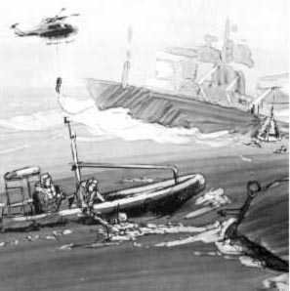
All prescribed life-saving appliances shall be made of non-combustible or fire retardant material
All prescribed life-saving appliances shall have marking in red colour
All prescribed life-saving appliances shall be of such a colour that they are in contrast to the surrounding colour
All prescribed life-saving appliances shall be fitted with the manufacturers name and Logo

113. What is the purpose of the O.D.M.E. (Oil Discharge Monitoring Equipment) printer ?

To prove that the O.D.M.E. system has been used
None of the mentioned
To prove fault conditions in the O.D.M.E
To prove that oil has been pumped overboard according to regulations

114. The mandatory color of a hand flare is:
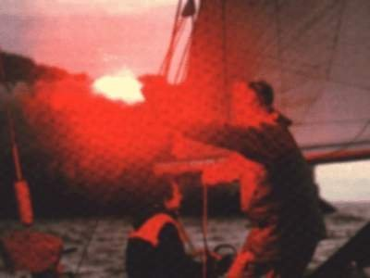
Red
Green
White
Yellow

115. Which of the functions is this operational amplifier circuit performing?
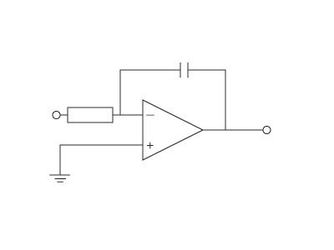
Integrator
Inverting amplifier
Differentiator
Non-inverting amplifier

116. Why is it important to reduce the diesel engine load during in service water washing of the turbocharger gas side?
To avoid cold corrosion of exhaust system.
To prevent damage to the turbine blades
To reduce the air pressure to the water dosage pot.
To prevent overload of the turbocharger bearings.

117. From the options given, choose the one most likely to result in a high exhaust gas temperature in one cylinder of a four stroke diesel engine.
Fuel injection valve opening pressure set too high.
Faulty turbo charger.
Clogged nozzle holes in the fuel injection valve.
The inlet and exhaust valve tappet clearance is incorrect.

118. What is the minimum number of channels required for the portable two-way VHF's for survival craft?

Channels 16 & 12
Channel 16 only
Channels 6, 12 & 16
Channels 6, 13 & 16

119. A triac is used to provide temperature control of an oven. The galley complain that the oven only reaches approximately 50% of demanded temperature. Which of the following is a likely cause?
The voltage supply to the oven controller is reduced by about 50%
The triac has completely failed.
Connection between the demand knob and the triac gate terminal has gone open circuit.
One of the main switching elements in the triac has failed.

120. The muster list must be prepared:
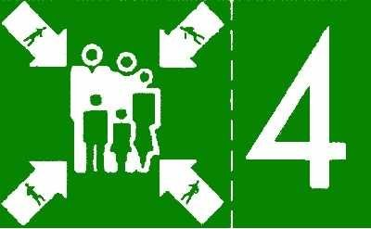
At any moment before the ship proceeds to sea
at least 2 hours after the ship has proceeded to sea
at least 2 hours before the ship proceeds to sea
at least 1 hour before the ship proceeds to sea

121. Which of the following symptoms would indicate that the filter drier in a refrigeration circuit has become blocked?
A large temperature drop across the drier.
A pressure rise before the drier.
A hammering noise from the drier.
A hammering noise from the compressors.

122. Which of the following requirements to ships stability for normal operation corresponds to present regulations? (NSCL 4/12.2)
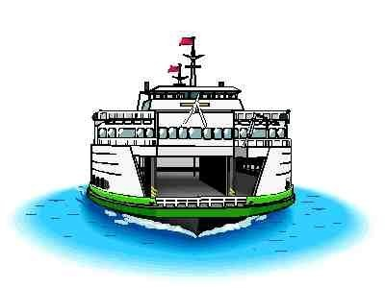
Unless otherwise stated in the approved stability calculation, the total weight of the deck cargo shall not exceed 50 metric tons.
The ship is loaded in such a manner that adequate stability is achieved in all loading condition.
In waters with the danger of icing, loading of deck cargo must be approved by competent authority.
Centre of gravity shall be calculated with accuracy better than 5 percent.

123. Severe piston ring and liner wear are experienced in two cylinders of a medium speed diesel engine shortly after a complete overhaul of all of the cylinders of the engine. The engine is fitted throughout with chrome plated cylinder liners. Which of the given options is the most likely cause of the excessive wear in the two cylinders?
Chrome plated piston rings have been mistakenly fitted to the two cylinders.
Cast iron piston rings have been mistakenly fitted to the two cylinders.
The running in period for the engine was too short.
The oil control rings have been fitted upside down in the two cylinders.

124. A vessel is scheduled to enter a SECA during a forthcoming voyage? What additional considerations must a Chief Engineer take into account when planning for this voyage?
That all garbage is fully disposed of prior to entry into the SECA and suitable arrangements are made for retention while in the SECA.
That there is sufficient room in the bilge holding tank to ensure no discharges of machinery space bilges takes place while the vessel is in the SECA.
That the incinerator is shut down for the duration of the time the vessel is in the SECA.
The availability of low sulphur fuel and the change over time required to ensure the system is clear of normal fuel prior to entry into the SECA.

125. Select the option which correctly completes the following statement. 'Prior to allowing work to proceed in an onboard space testing of the atmosphere should be carried out...
..only if the space has contained liquid oil at some point.
...only if the space has a watertight door or watertight access opening.
...only if the space has been used to carry any cargo or contains any cargo related equipment.
...for any space with limited access or non-continuous ventilation or is suspected of having a hazardous atmosphere.

126. When reasonable and practicable, how often shall rescue boats be launched with their assigned crew aboard and manoeuvred in the water?
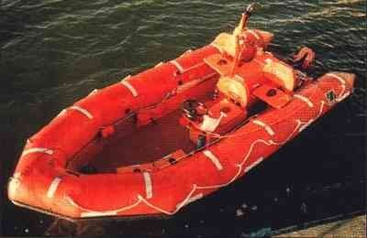
Every month
Every two weeks
Every six months
Every week

127. Over a period of a few hours of operation the main diesel engine speed gradually falls off. From the options given what is the most likely cause of this fault?
Fouling of turbocharger intake filters.
Injection valve opening pressure is too low.
Governor linkage broken.
Water in a cylinder.

128. Below shows a typical shore supply connection box. What does device SSA stand for?
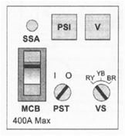
Shore supply available lamp
Ship supply available lamp
Switchboard supply available lamp
Sequence supply available lamp

129. The continuity resistance of a 100m long X 25 sq. mm cable (rated at 100A) is to be checked. Which of the following results would you anticipate?
between 0.1 and 1.0 ohm
between 0.1micro ohm and 1.0 micro ohm
greater than 1 M ohms
between 0.1 and 1.0 M ohm

130. What does the term 'stoichiometric mixture' mean when used in relation to combustion of hydrocarbon fuels?
A ideal mixture of fuel and air in which all of the fuel in the mixture is consumed during combustion.
An ideal mixture of fuel and air in which all of the fuel and oxygen in the mixture are consumed during combustion.
A ideal mixture of fuel and air in which all of the oxygen in the air in the mixture is consumed during combustion.
An ideal mixture of fuel and air in which all of the fuel in the mixture is consumed during combustion with a minimum of excess air.

131. In control systems it is often necessary to convert from one type of unit to another. Which is a common signal level for an I/P converter?
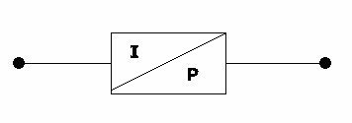
0-20 mA/0-20 PSI
0-10V/3-15 PSI
0-1 mA/1-2 BAR
4-20mA/3-15 PSI

132. Maintenance is to be carried out on a diesel engine. How long after stopping the engine should the cooling water and lubricating oil be kept circulating in order to avoid any undue thermal stress from residual heat?
At least 8 hours
At least 24 hours.
At least one hour.
10 minutes is sufficient.

133. When the vessel is operating in a tropical area with very high humidity, what action should be taken to deal with the expected increase in condensate from the main diesel engine's charge air cooler?
Reduce the engine load to minimise condensate from the air cooler.
Increase the scavenge air temperature to minimise the condensate from the charge air cooler.
Ensure that condensate drains from the water separator are monitored and operating correctly.
Decrease the scavenge air temperature to minimise the condensate from the charge air cooler.

134. During inspection of the main bearing shells and housings of a medium speed diesel engine it is found that there is evidence of fretting at some of the bearing shell joint faces, the bearing housing joint faces and also between the back of the bearings and the bearing pocket. From the options given which is the most likely cause of these defects?
Operating with a faulty torsional vibration damper.
Excessive tightening of the main bearing bolts
Insufficient tightening of the main bearing bolts.
Running the engine overloaded.

135. When should a crew member joining a ship for the first time be given some training and instructions in the use of the ship's fire-fighting appliances ?
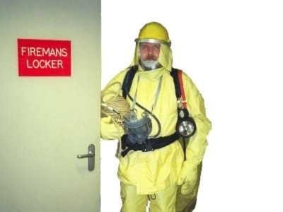
As soon as possible but not later than 2 days after he joins the ship
As soon as possible but not later than 24 hours after he joins the ship
As soon as possible but not later than 2 weeks after he joins the ship
As soon as possible

136. Prior to removing the access doors to a pressure vessel for internal maintenance it should be ensured that all pressure has been relieved. As well as a zero indication on a pressure gauge which other measure, from the options given should be taken to confirm this prior to commencing the work?
Open the drain valve while pressure still shows on the gauge and to check it is clear. Outflow should cease as the pressure gauge reaches zero.
Open the drain valve when the gauge reads zero to check that there is no outflow.
Back of the tensioning device for the relief valve to vent the pressure to atmosphere.
Open the drain valve and when the outflow stops slacken off the drain valve flange bolts and 'crack' open the flange in case the drain is blocked.

137. In the event of a diesel engine crankcase explosion which of the safety devices fitted to the engine is designed to minimise the risk of a secondary explosion?
Crankcase extraction fan.
Main bearing temperature monitoring equipment.
Crankcase oil mist detector.
Crankcase relief valves/doors

138. A High Breaking Capacity fuse found in a Main High Voltage Switchboard will typically have fault level rating of ?
4000A
40 kA
40A
400A

139. In a closed loop control system the error signal is derived from which of the following?
The process and the demand
The tolerance of the feedback sensor
The demand and the feedback signal
The process and the feeedback sensor

140. A thermistor which provides feedback for a thermal control system is suspected to have failed. Assuming there is no available direct/identical replacement for thermistor, which of the following methods may be used to prove it has failed?
Disconnect the thermistor lead from the controller and replace with a mV source.
Connect a mA source in parallel with the thermistor connections.
Disconnect the thermistor lead from the conttroller and replace with a mA source.
Connect a mV source in parallel with the thermistor connections.

141. Who are responsible for safe working conditions onboard?

The officer of the watch.
Master, Chief Engineer & Chief Officer.
The individual person.
The safety officer.

142. Who can contact the Designated Person with their safety concerns?
Senior officers only
The company's shore staff only
The Master only
All crewmembers

143. The fuel consumption for the main engine is calculated using the readings from the supply and return flow meters which are of the positive displacement type. When compared to the quantities calculated from tank soundings and calibration tables and indicated on the contents gauges the consumption appears consistently high. Which of the options given is the most likely cause of this discrepancy?
The supply flow meter is giving too high a reading due to internal wear.
The tank calibration tables are incorrect.
The return flow meter is giving a low reading due to internal wear.
The tank contents gauges are calibrated for the wrong fuel type.

144. In the circuit diagram shown the starter connects between which terminals?
1 and 2
7 and 8
5 and 6
3 and 4

145. New MARPOL regulations came into effect from July 93 stating that the oily water separator which was previously certified for 100 ppm be changed to:
50 ppm
25 ppm
10 ppm
15 ppm

146. What is the best method for ensuring that the cylinder powers of a high speed diesel engine, fitted with a monoblock multi-cylinder fuel pump, are correctly balanced?
Check the exhaust temperatures on each cylinder to see if they are equal.
Take a set of indicator cards using a mechanical indicator and calculate the cylinder powers.
Have the fuel pump phased and calibrated in a test workshop.
Measure the maximum pressure of each cylinder to check that they are equal.

147. Low voltage ships tend to have insulated neutral systems. What is the reason for this?
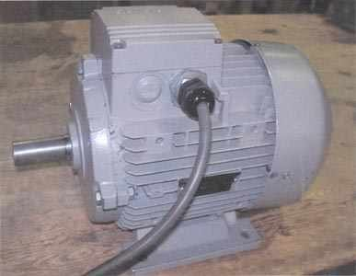
If the neutral is not insulated then it may short to other conductors.
It is more effective than insulating the live conductor
In the event of an earth fault vital equipment will not trip
It is easier to detect faults

148. What is the likely cause of a decrease in the pH-value and an increase of the sulphate content of a diesel engine's cooling water system?
Leakage from the lubricating oil coolers.
Seawater leakage into the cooling water system
Exhaust gas leakage into the cooling water system.
Overdosing of corrosion inhibitor treatment chemicals

149. In what language/languages must the fire control plans or booklets (or copies of these) be written?

In the Flag State official language with copies in English or French
In a national language where company head office is located
In the Flag State official language
In the English language

150. When bunkering through the port side of the bunker manifold what action should be taken with the valves on the starboard side of the manifold prior to bunkering operations commencing?
Blank flanges should be fitted to the closed starboard side manifold valves.
The blank flanges should be removed from the starboard side manifold valves to check for any leakage past the closed valves.
Just check that the valves are closed.
Just fit the blank flanges then it doesn't matter if the valves are closed or not.

151. To avoid overbunkering and oil spill, it is very important that we closely monitor the progress of the bunkering operation. What is the safest method to use to minimise the risk of overflow and spillage?
Use the predicted loading rate to calculate how much oil is being received.
The remote gauge system will provide us with the necessary information
Continuously monitor remote guage readings and confirm with regular sounding of the fuel tanks.
Open all the bunker tank lids to manually watch them filling.

152. An important quantity which is useful in circuit analysis is known as conductance G (Siemens). Which of the formulas A to D expresses the conductance for this circuit?
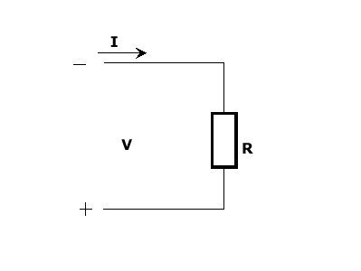
G = I /R
G = 2 R
G = R * I
G = 1/R

153. Notification logging procedures .(OPA-90)
Only communication with USCG
Only verbal reports for documentation
Every report or message must be logged including time and date
Only initial reports to be logged

154. What effect would turbulent fluid flow through a heat exchanger have on the efficiency of the heat transfer?
It cannot be determined since it is not possible to generate turbulent fluid flow through a heat exchanger?
Turbulent fluid flow generally increases heat transfer efficiency.
Heat transfer efficiency is not affected by the type of fluid flow through the heat exchanger.
Turbulent fluid flow generally reduces heat transfer efficiency

155. The circuit shows a full-wave bridge rectifier. Which electronic component should be connected between 'a' and 'b' in order to obtain reduced ripple voltage to the load RL.
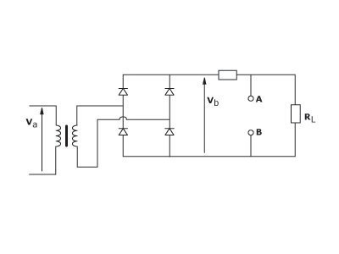
Capacitor
Zener diode
Inductive reactor
Resistance

156. The auxiliary boiler for the supply of low pressure heating steam has an automatic combustion control which operates on a two step control principle. The boiler fails to attempt to start up during a period of normal operation even though the steam pressure has fallen below the set point. What is the most likely cause of this fault?
The pressure switch for the combustion air supply is faulty and remains open.
The electrical supply for the control system is isolated.
The pressure switch for low steam pressure is faulty and fails to close.
The photocell for detecting flame on is dirty.

157. Which type of profiling is used to obtain information about rival companies and their employees?

Commercial
General
Criminal
Industrial

158. The temperature of the feed water for an auxiliary boiler is automatically controlled by a pneumatically actuated steam valve at the inlet to the pre-heater. It is noticed that during high demand the temperature falls by an unacceptable amount and takes a long time to return to the set temperature even though the steam supply pressure remains constant. Select from the options given the most likely cause of this.
The control air pressure regulator is set too low.
The controller proportional band is set too wide.
The controller proportional band is set too wide and the reset time is set too long.
The controller reset time is set too long.

159. A temperature control system is exhibiting hysteresis. Checks on all of the system components show that they are functioning correctly. Which of the changes/modifications given in the options is most likely to correct this problem?
Fit a new temperature sensor with a narrower temperature range.
Increase the pressure of the air supply to the controller.
Fit a valve positioner to the system.
Slacken off the control valve gland.

160. Which is the preferred method for starting an air conditioning refrigeration compressor which has been shut down for a period of time?
Start with all system valves fully opened.
Start with the discharge valve throttled in to prevent excess condenser pressure.
Start with suction valve throttled in to minimise risk of drawing liquid refrigerant into the compressor.
Start and stop repeatedly until suction pressure and oil pressure are normal.

161. The muster list shall show the duties assigned to the different members of the crew. Which of the given duties necessarily have to be included in the muster list?

Preparation and launching of survival crafts
Type of fires that can be encountered on board
Clearing escape routes
Preparation and starting of emergency generator

162. A plate type heat exchanger in a central cooling system has seawater leaking around the edges of some of the titanium plates. After inspection and reassembly following the manufacturer's instructions the problem still exists. What action, from the options given, should be taken to rectify the problem?
Reduce the pressure of the sea water.
Keep tightening the plate stack until the leakage stops.
Fit new gaskets to the each of the plates.
Scrap the plates and replace with a new plate stack.

163. High Voltage systems rely on the installed protective equipment being able to interrupt any fault in the system. Throughout the system, the fault level has been calculated, and under no circumstances must the system be modified to exceed this fault level. What is meant by fault level?
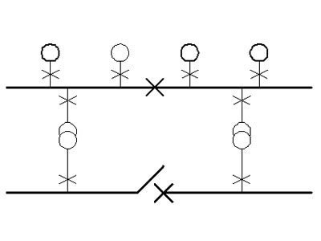
The current level flowing into a dead short to earth at any point on the ship, directly from the High Voltage system.
The amount of apparent power, that would be drawn from the generating plant, when a short circuit occurs at the bus bars.
The amount of apparent power that could flow into any fault at any point in the electrical network.
The current level flowing into a symmetrical short circuit fault between all three phases.

164. Fluid flow is measured using a pneumatic differential pressure transmitter and is indicated on a direct reading instrument. The indicator is reading zero even though fluid is flowing through the system. When the flow rate changes the indicator initially registers a reading but then gradually returns to zero. From the options given select the probable cause of this condition.
The I/P converter is faulted.
Diaphragm in the differential pressure transmitter is perforated.
The connection to the differential pressure transmitter low pressure bellows is blocked.
The connection to the differential pressure transmitter high pressure bellows is blocked.

165. When carrying out repair or maintenance tasks involving hot work a hot work permit must be issued. Select the correct option from those given which completes the following statement. 'The permit for hot work...
..should only cover specific hot work tasks and be valid for a specified time period.'
..is valid for completion of the specific hot work tasks irrespective of the time taken.'
..can cover any additional hot work that arises during the completion of the task during the specified time period.'
..should only cover specific hot work tasks, be valid for a specified time period and be issued by the person carrying out the work.'

166. Oil analysis results for a sample of diesel engine lubricating oil show a high level of tin. What could be the possible cause?
Debris from fretting between bearing housing parts
Debris from damage to a white metal bearing.
Cylinder oil contamination of the lubricating oil system.
Debris from damage to a rolling contact bearing.

167. Which one of the listed requirements regarding service and maintenance of life-saving appliances correspond to present regulations?
Maintenance and repair of all life saving equipments shall be carried out by the certified ship staff only
Maintenance and repair of all the life-saving equipments will be carried out ashore in work shop only
At least one member of the crew shall hold a repairman certificate for life-saving equipment
Instructions for onboard maintenance of life-saving appliances in accordance with the regulations shall be provided

168. What is the minimum number of portable two way VHF walkie talkies for use in survival craft, that should be carried onboard vessels which comply with GMDSS regulations?
2 sets
There is no requirement to carry them.
1 set
3 sets

169. Why is it important to make weekly/routine rounds in the accomodation areas?

To search for any contraband goods hidden on board
To check for alcohol in cabins
It is a requirement as per flag state
To ensure that cabins and common spaces are maintained in a clean, safe and hygienic condition

170. A current measuring instrument has low impedance Zi. If the source impedance, Zg is much higher than Zi, what would be the relative measurement error?
Zi / Zg
- Zi / Zg
-Zi / (Zi + Zg)
Zi / (Zi + Zg)

171. On-board training in the use of davit-launched liferafts (including inflation and lowering whenever practicable) must take place
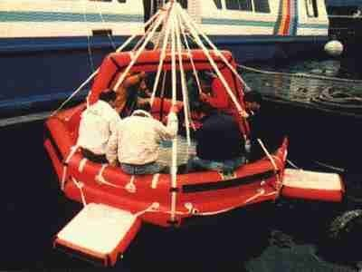
every month
every 3 months
every 2 months
every 4 months

172. Which one of the following is not a common maintenance requirement of induction motors?
Ensure motors' external and internal hygiene is maintained
Ensure that insulation resistance are kept high
Lubricate the motors correctly and maintain an even air gap
Have the motors' instruments changed every year

173. What is usually the effect on G when the ship is damaged with water ingress?
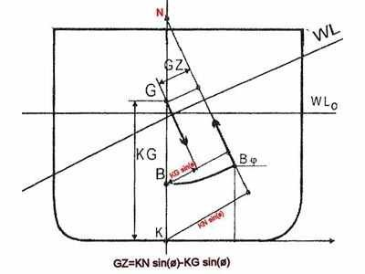
It is unchanged
It first rises then lowers
It rises
It lowers

174. Which of this information must be included in a piracy attack alert?

The number of pirates/highjackers.
Your ship's name and call sign.
The type of weapons being carried by the pirates/highjackers.
The number of crew onboard.

175. Which of the following is not a methods of checking running motors for condition monitoring?
Monitoring vibration due to defective bearings
Measurement of insulation resistance
Measurement of short circuit current
Temperature of motor

176. What colour flare is used to signal a safe landing place for small boats ?
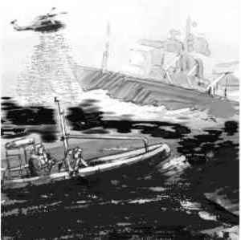
Green
Blue
White
Yellow

177. What does ISM stand for?
Internal Ship Safety Management
The International Management Code for the Safe Operation of Ships and for Pollution Prevention
International Safe Manning Certification
International Ship Measurement and Pollution Control

178. During inspection and overhaul of a 2-stage reciprocating air compressor the main and bottom end bearing shells are found to be heavily scored with parts of the overlay and bearing metal breaking away. The crankshaft pins are found to have only very light surface scratches. Which of the given options is the best action to be taken to remedy the problem?
Replace the bearing shells with new spares after cleaning out the crankcase and refilling with clean oil.
Refit the shells and refill the crankcase with clean oil and run the machine so that the bearings wear themselves back in.
Replace the bearing shells and crankshaft with new spares and refill the crankcase with clean oil.
Clean up the bearing surface and crankshaft pins with scrapers and grinding paste and refit them. Refill the crankcase with clean oil.

179. During inspection of the crankshaft of a medium speed diesel engine cracks are discovered at one of the main journal pins. The cracks originate from one of the oil holes and are progressing along the pin at approximately 45 degrees to the axis. From the options given select the most likely failure mode that would cause this.
Fatigue due to repeated excessive bending of the crankshaft.
Torsional fatigue due to excessive torsional vibration in the crankshaft.
Shear due to excessive loading of the crankshaft.
Erosion due to excessive oil flow through the oil hole in the crankshaft pin.

180. Which of the following is an application of an capacitive sensor?
Barometer
Proximity sensor
Tachometer
Piezoelectric sensor

181. What do you understand by the term Maximum Continuous Rating, MCR, of a diesel engine?
The maximum load that the engine can operate at continuosly.
The maximum speed that the engine can operate at continuously.
The maximum charge air pressure that the engine can operate at continuously.
The maximum cylinder pressure that the engine can operate at continuously.

182. Which of the 4 alternatives shows a NPN bipolar transistor?
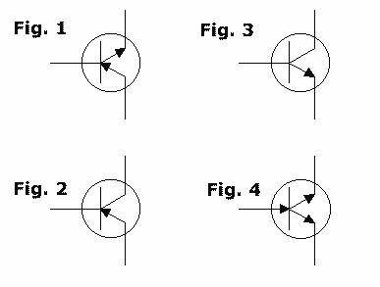
Figure 1.
Figure 3.
Figure 2.
Figure 4.

183. A tachometer for a diesel engine is reading erratically. The tachometer is of the non-contact type using magnetic proximity switches to generate the signal. What is the most likely cause of this problem?
The proximity switch has dirt on the outside casing.
The shaft magnet has fallen off.
The proximity switch is loose on its mounting.
The shaft magnet has become demagnetised.

184. Which of the given options for the value of differential pressure across a lubricating oil filter for a medium speed diesel engine would indicate that the filter required cleaning?
1.0 Bar
Zero
4.0 Bar
0.2 Bar

185. It is noticed that some of the items that were to be used to lift some machinery components during a maintenance routine had not been tested for over 5 years. Which of the options given is the correct action to be taken in a situation like this?
Mark the items as not to be used and store them securely until they can be tested by a competent person.
Return them to the lifting gear locker and make a note in the Register of Lifting Gear that they need to be tested.
Have them inspected immediately by a competent person so that they can be used for the task.
Scrap the items immediately as they are unusable once they have not been tested for 5 years.

186. A U tube manometer is used to measure the pressure delivered by a ventilation fan. Following replacement of the fan by a larger unit with a higher delivery rate and pressure the liquid is blown out of the open end of the manometer. Which of the options given will allow the manometer to be used to measure the delivery pressure of the larger fan?
Connect the open end to the inlet trunking of the fan to measure the differential pressure rather than the delivery pressure.
Refill the manometer with a reduced amount of liquid.
Refill the manometer with liquid with a higher viscosity
Refill the manometer with liquid with a higher density.

187. Your vessel has been involved in a collision, and at first opportunity a lot of people from outsides parties are asking questions. What shall you tell them?
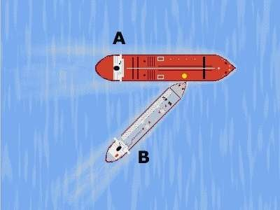
Do not reply to any questions from outside parties, except the Solicitor appointed by your company.
To make sure that all parties are informed about the facts, show them the extracts of the log-book.
Do not tell anybody anything, except representatives from the main newspapers, radio and TV. Remember, the people have the right to know.
You shall only tell them the truth and nothing but the truth.

188. Which of following items shall be included in an abandon ship drill?
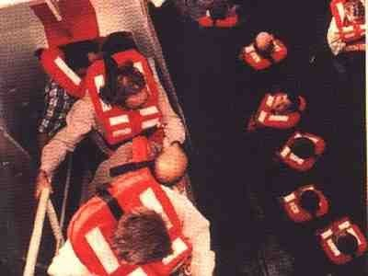
Checking passenger's immersion suits
Checking the lifeboat provisions and supplies
Checking the distress signal rockets and other distress signals
instruction in the use of radio life-saving appliances

189. The water cooling space on a turbocharger is damaged and there is no spare casing. The cooling water must be shut off. Which option would you take to keep the risk of further damage to a minimum?
Dismantle the rotor and assemble the sealing plates.
Make no modifications, but tell the duty engineer to pay special attention for abnormalities.
Cool the turbocharger by means of air.
Run the engine at a lower speed.

190. Why should the coil of an ac solenoid valve not be energised when it has demounted from the valve body?
The coil will lose it's residual magnetism
The coil will overheat.
The coil will fail due to vibration.
The coil will jump around.

191. A high speed diesel engine has been subject to a major overspeed incident due to governor failure. During checks for damage it is found that some of the bottom end bolts have slackened off slightly. There appears to be no other damage to any of the bearings, the running gear or to the crankshaft. From the options given select the action to be taken before bringing the engine back into service.
Renew all of the bottom end bolts that were found slack.
Renew all of the running gear for the engine including the crankshaft and bearings.
Renew all of the bottom end bolts.
Retighten the bottom end bolts that were slack back to the recommended torque.

192. What is a "passenger" according to SOLAS regulations?

Everyone who travels with a passenger ship
Any person paying their voyage regardless of ship type
Any person holding a ticket and travelling with a passenger ship
Every person other than the Captain and the members of the crew or other persons employed or engaged onboard the ship in the business of that ship.

193. You are in charge of a night bunkering operation. The delivery rate from the supplier is high and you are filling six tanks simultaneously. You lose track of the progress of the operation and feel that you are losing control of the situation. What action should you take?
Stop bunkering, and establish facts, before bunkering is resumed
Request a reduction in the delivery rate to try and gain some time.
Prepare yourself and the crew for an overflow.
Open more tanks to slow down the filling rate of individual tanks.

194. Which of the following methods may a diode may be tested by?
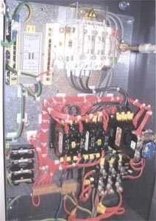
Use a Digital Multi- Meter set to measure ohms in forward and reverse directions.
Use an insulation resistance tester (Megger)
Use a Digital Multi-Meter set to check forward voltage and reverse current blocking
Connect to low ohms resistance tester.

195. Are there any exceptions from OPA-90
No exceptions
Yes, transit passage through US waters to a non US port
Yes, close to any US naval base
Yes, if the vessel calls a US port for only a short stop

196. The cold room temperature is almost at the cut out point in a vapour-compression refrigeration system. What should the refrigerant state be just after the evaporator if the system is correctly set up?
Cold liquid at high pressure.
Wet vapour at high pressure.
Slightly superheated low pressure gas.
Sub-cooled liquid at low pressure.

197. Ships of 10.000 tons gross tonnage and more, shall be fitted with oil filtering equipment, complying with Reg.14 (7) of MARPOL for the control of machinery space bilges. What would be the maximum oil content of oily-water mixture to pass through the filter?
100 ppm
30 ppm
15 ppm
60 ppm/n.m

198. How is the prime mover load normally kept to a minimum when starting up an electric driven reciprocating type air compressor?
By keeping the main discharge valve closed until the machine is up to speed.
By keeping the second stage drain valve open until the machine is up to speed.
By using an unloading device to keep the compressor suction valves open until the machine is up to speed.
By using an unloading device to keep the compressor delivery valves open until the machine is up to speed.

199. A 3-phase cage rotor induction motor requires protection by a time delay overload trip. What is the reason for this?
Fuses act too quickly
Fuses act too slowly
It will allow for inrush current or motor specific faults
It will tolerate fault conditions during start up

200. The critical part of any bunkering operation may be considered to be when topping off the tanks at which stage the risk of overflow and spillage of fuel oil is greatest. What is the correct safe procedure to adopt to minimise this risk?
Reduce the bunker delivery flow rate and top off the tanks one at a time.
Top off all of the tanks together to reduce the inflow rate into each tank.
Shut off each tank as it overflows into the fuel oil overflow tank.
Watch for oil coming up the sounding pipe and shut the tank valve just before it overflows.

201. The temperature control for a hot water system is very erratic with the temperature gradually rising and then suddenly falling and vice versa even though system demand is fairly constant. Which of the options given is the most likely cause of this problem?
Control valve actuator diaphragm is ruptured.
Controller integral action reset time is too fast.
Control air pressure supply is too low.
Control valve gland is over tightened.

202. When carrying out routine insulation testing of a three - phase induction motor, which of the measurement should be covered?
U-V-W-E
AA-E, ZZ-E
U1-U2, V1-V2, W1-W2, U-E, V-E,W-E
U-E, V-E, W-E, U-V,V-W, W-U

203. How is a Safety Management Certificate obtained?
Ship owner is authorised to carry out internal audits and issue SMC
Vessel is surveyed by MCA and certificate issued
RSS issue SMC with Register
Ship owner has Document of Compliance issued, and vessel is assessed and holds all statutory certificates

204. Prior to the lunch break, the Engineer on Duty observes that the operating generator set has an output of 90%. With regard to operation of the generator, what is the - most important - assumption(s) for him to check before switching to UMS-mode?
That all operating parameters of the generator set in operation are normal (e.g. exhaust temp, lubeoil pressure, cooling water temperature etc.)
All parameters as listed under the other alternatives.
That a secondary auxiliary set is switched to automatic standby mode
Visually checking the auxiliary engine that there are no leaks or other obvious operating failures

205. It is the Master's responsibility to ensure that:
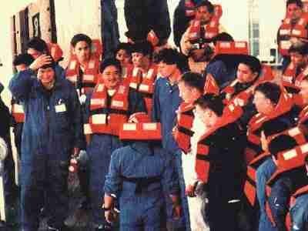
concerned personnel carry out the on-board traing progamme effectively
All information reagrding the onboard training is given to the ship manager
safety equipment is not used during the training
All personnel participate in the training at the same time

206. Which of the following is not a fault rating of the circuit breaker?
Asymmetrical breaking current
Short circuit current
Symmetrical breaking current
Making current

207. Sometimes an early warning of failure in High Voltage switchboards may produce an unpleasant smell. If the switchboard uses gas circuit breakers, which type of unpleasant smell may indicate a potential problem?
Gas oil.
Rotten eggs.
Rotten fish.
Chlorine.

208. Which one of the given requirements regarding survival craft muster and embarkation arrangements corresponds to the present SOLAS regulations?
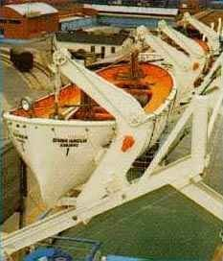
Davit-launched survival craft muster and embarkation stations shall be arranged to enable stretchers to be placed in survival craft.
Searchlights to be provided at the launching station.
Muster and embarkation stations are to be arranged separately to improve working conditions.
Muster and embarkation stations shall be readily accessible from accommondation and work areas.

209. Which of these statements about profiling is correct?

Verify that answers to questions match up with what's already known about the person being questioned.
Check the ID of all visitors and some crew prior to boarding.
Use only open-ended questions.
Pay less attention to body language and behaviour and more attention to answers to questions.

210. What is meant by dead ship condition?
Condition under which services needed to provide minimum living conditions are not working.
Condition under which the main propulsion plant, boilers and auxiliaries are not in operation due to absence of power
Condition under which any services needed for normal operational and habitable conditions are not working due to absence of main power
Condition under which ship as a whole is in working order and functioning normally.

211. What is the result of a "high metacentric height"?
The vessel will have a great bending moment?
The vessel will roll violently?
The vessel will roll slowly or be unstable?
The vessel's tweendeck heights is too high?

212. In terms of automated control systems, what is applicable for a continuous control system?
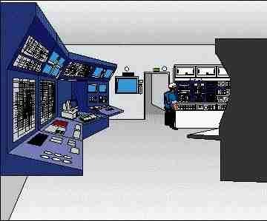
It is not possible to have a stable process
The output signal is equal to the input signal
Automatic control in which the controlled quantity is measured continuously and corrections are a continuous function of the deviation
The control valve will always be changing position

213. A transformer overheats while taking a shore supply. Which is the likely cause?
Incorrect current
Incorrect voltage
Incorrect frequency
Incorrect earthing

214. The steps of the embarkation ladder used must be proportioned as it follows:

length = 280 mm, breadth = 85 mm, depth = 10 mm
length = 380 mm, breadth = 145 mm, depth = 20 mm
length = 480 mm, breadth = 115 mm, depth = 25 mm
length = 580 mm, breadth = 165 mm, depth = 30 mm

215. Which of the following options is the most likely to result in the maximum cylinder pressure for all cylinders on a diesel engine to be lower than normal?
Poor quality fuel.
Camshaft timing advanced.
A leaking exhaust valve.
A worn fuel injector.

216. A non-reversing medium speed diesel engine is used to drive a controllable pitch propeller through a pneumatic clutch and reduction gearbox. The engine has been tested and brought up to operating temperatures on engine control. Which of the options given would be the preferred status of the engine and associated equipment when it is handed over to bridge control?
Engine running, clutch disengaged, propeller at zero thrust.
Engine stopped with clutch disengaged and propeller at zero thrust.
Engine running with clutch engaged and propeller in ahead position.
Engine stopped with clutch disengaged and propeller in zero thrust position.

217. Some vessels have a central hydraulic system consisting of a number of hydraulic power packs for driving cargo pumps, deck machinery, ship's cranes, etc. Which parameter is normally used to automatically bring the power packs on and off line to match operational demand?
Temperature of hydraulic fluid.
Percentage of available flow.
Percentage of maximum pressure being used.
Number of consumers running (pumps, etc.)

218. Which of the following functions does the diode shown here perform?
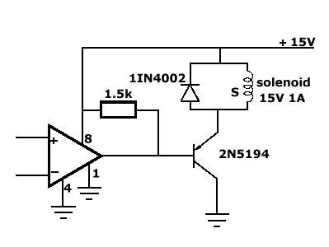
Return inductive current to supply at switch off.
Allow Op Amp to top up +15V rail.
Reference the transistor to +15V.
Provide an overload route for transistor current.

219. When starting up an aerobic type sewage unit for the first time, or after manual cleaning, how should the bacterial process be initiated?
By shutting off the air flow.
By filling the unit with sewage and bubbling air through it for 48 hours prior to starting the discharge pump.
By adding an activating agent to the inflowing sewage.
By bypassing the grey water inflow and operating only with black water.

220. A portable oxygen analyser for use onboard ship is of the paramagnetic sensing element type. It is being used to test the atmosphere of a space onboard ship but starts to give erratic readings. There is no obvious indication as to why this is happening. Select from the options given the most likely cause of this problem.
The sampling filter is partially blocked giving rise to wide pressure variations in the sampling chamber.
The sampling filter is blocked preventing gas from entering the sampling camber.
The battery power is low.
Nitrogen gas is present in the atmosphere.

221. The turbocharger on a diesel engine is surging and making occasional, loud "whoofing" noises. Which one of the options given is the most probable cause of this?
Rapid changes in engine load due to rough sea conditions.
Exhaust system recently cleaned.
Engine on bridge control.
Air leakage from scavenge receiver.

222. During test and/or maintenance work of the CO2 system affecting the release system, precautions to ensure that the gas is not released into the engine room due to a mistake are to be ensured. What precautions should be taken?
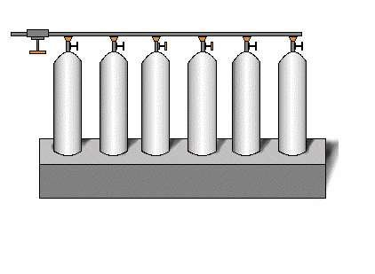
Check the main valve for a potential leakage.
Arrange a watchman in the CO2 central.
No special precautions necessary.
The main supply line to be blanked off prior to the work.

223. What is signal attentuation?
Reduction in the signal's strength or amplitude
Reduction in signal's noise
Reduction in signal's transmission distance
Weakening of signal's control

224. Electric arc welding is to be carried out in the machinery spaces other than the workshop. Which of the alternatives below would be the preferred method for the connection of the "return" cable to the welding set?
Use a "go and return" system with the return cable connected directly from the welding set to the work piece if possible.
Have a short length of cable permanently connected to the ships structure close to the welding set.
Weld a stud bolt close to the work piece and connect the return cable to this.
Move the welding set to the welding site.

225. As per SOLAS regulations, the general emergency alarm system must be tested:
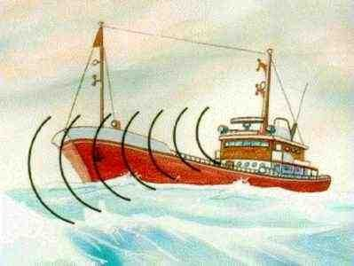
Every 2 weeks
Every month
Every 3 weeks
Every week

226. Which of the following sensor type is preferred for detecting smoke from fire?

Thermometer
Ionization type
Strain gauge
Thermocouple

227. A test of the lubricating oil in an auxiliary diesel engine shows that the viscosity is low. What is the most likely cause of this?
Contamination with heavy fuel oil.
Contamination with seawater.
Contamination with distillate fuel oil.
Contamination with freshwater

228. On an oil tanker outside a special area, what is the maximum instantaneous rate of discharge of oil content per nautical mile?
60 litres per nautical mile.
30 litres per nautical mile
20 litres per nautical mile.
40 litres per nautical mile.

229. "Protective discrimination" means the progressive grading of sizes or tripping times of:
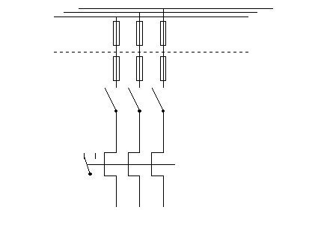
Line fuses and overcurrent relays
440 V and 220 V transformers.
Magnetic and thermal current transformers.
Generators and motors.

230. A positive displacement type flow meter is defective and cannot be repaired. It is to be replaced with a new instrument which uses a Venturi type sensor. Which of the pneumatic relays given in the options will be required in order for this type of instrument to function correctly?
Multiplier relay.
Summation relay.
Square root extractor relay.
Subtraction relay.

231. What type of Ex equipment is suitable for installation in Zone 0 hazardous area?
Ex i
Ex p
Ex d
Ex m

232. The exhaust temperature on one cylinder of a diesel engine is high; what is the most likely cause of this?
Leaking inlet valves.
Reduced fuel delivery from fuel injection pump.
Leaking exhaust valves.
Insufficient cylinder lubricating oil feed to the cylinder.

233. In many cases the ship's Chief Engineer can carry out survey of machinery on behalf of a Classification Society under arrangements covering Continuous Surveys. As part of this arrangement a Surveyor from the Classification Society must carry out a periodic audit of the documentation for the approved planned maintenance system and undertake a confirmatory survey of the items surveyed. What is the normal frequency for this audit?
Every 5 years
Annual.
Bi-annual.
Every 4 years.

234. The Master is responsible that all crew participate in monthly emergency drills. If 25% of the crew - or more - has not participated in such drill during the last month, what is the time limit to conduct such a drill after the vessel has left a port?
Within 48 hrs
Within 12 hrs
Within 30 hrs
Within 24 hrs

235. In case of pollution in US waters, do you always have to notify the National Response Center (OPA-90)
Yes, within thirty (30) minutes
No, not if the local US State Authority is correctly notified
No, only the shipowner can notify NRC
Yes, within three (3) days

236. What type of piping line does below figure represent?
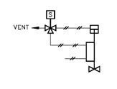
Hydraulic line
Pneumatic air line
Electric heat tracing line
Inert gas line

237. The operation of a diesel engine is controlled by a mechanical-hydraulic, compensated speed sensing governor. How will the governor control be affected if the compensation needle valve is closed in and the engine load changes?
A change in load will not affect a speed sensing governor.
Engine speed control will be sluggish.
The governor will hunt resulting in erratic engine speed control.
Altering the compensation needle valve has no effect on speed control.

238. In a PID controller the setting of the Proportional band (P), the Reset time (I) and the Rate time (D) may be adjusted. Please indicate which curve shows the typical response to a change in input, if the setting of the proportional band is too wide.
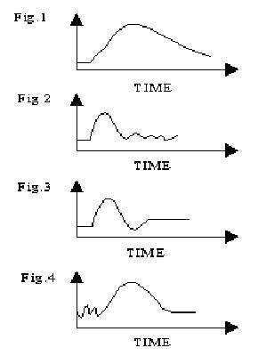
Figure 1.
Figure 4.
Figure 3.
Figure 2.

239. The engine turns over normally when starting air is supplied but does not fire even though normal starting rpm is achieved. What could be the probable cause to this?
The turbocharger has not run up to normal full speed.
Air in the fuel oil system.
The lubricating oil temperature is low.
The turning gear interlock has operated.

240. Which of the following options is the most likely cause of high exhaust gas temperatures in all cylinders of a diesel engine?
Water in the fuel supply.
Worn or broken piston rings.
Faulty high pressure fuel pump on one of the cylinders.
Partial blockage in the exhaust gas system.

241. Most medium and high speed diesel engines operate with mean piston speeds greater than those for larger slow speed engines. What is the main design feature of these engines which allows the higher mean piston speeds to be achieved without causing unwanted failures?
Using cast iron single piece piston crowns with a short piston skirt.
Using composite pistons featuring steel crowns and alloy skirts
Using directly cooled piston crowns with long piston skirts.
Fitting bronze rubbing bands to the piston skirts.

242. HEL-H is the abbreviation of a heavy helicopter radius of action for rescue purposes. What do you think the radius and evacuating capacity of the helicopter is?
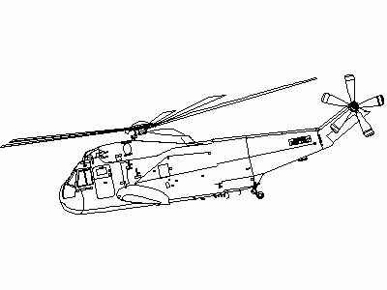
500 nm and capacity for evacuating more than 25 persons.
200 nm and capacity for evacuating more then 15 persons.
100 nm and capacity for evacuating more than 10 persons.
150 nm and capacity for evacuating more than 12 persons.

243. Which of the following duties shall be included in the "muster list" as being assigned to members of the crew ?
Operation of the vessel's propulsion system
Preparation of immersion suits for the ship's passengers
Preparation and launching of the survival craft
Preparation of manoeuvres intended to ease launching of the survival craft

244. Can a ZENER BARRIER be installed in a hazardous area?
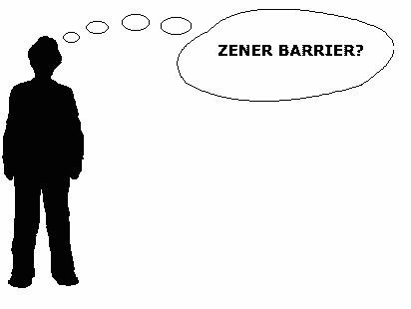
No, as only the output from the barrier is intrinsically safe this is not allowed.
Only if properly marked for such installation.
Only in equipment operating on very low voltage.
Yes, that's what the zener barrier is made for.

245. Part of the outer surface of a refrigeration compressor crankcase and the refrigerant return line near the compressor ice up heavily during normal operation. Which of the options given is the most likely cause of this problem?
The seawater flow control valve for the condenser is faulty allowing insufficient cooling water flow.
The filter drier unit in the liquid line is partly blocked.
The oil separator is not functioning correctly and is allowing lubricating oil to pass into the system.
The superheat control setting for the thermostatic expansion valve is set too low.

246. How often shall each member of the crew participate in an "abandon ship"-drill?

Once every month
Once every 6 months
Once every week
Once a year

247. Which of these actions should you take it your ship is successfully boarded by armed pirates?
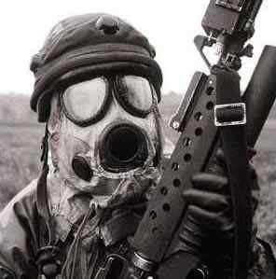
Assure your captors that you're not planning an attack to overthrow them.
Fight back.
Scream in fear and refuse to cooperate.
Keep quiet and ignore any questions you're asked.

248. Some new maintenance routines are being planned and a risk assessment is necessary so that the required procedures can be entered into the ship's Safety Management manual. Which of the following should be the first step in this risk assessment process?
Identify who may be harmed or injured in carrying out the maintenance routines.
Identify the hazards that may exist which may affect personnel involved with the maintenance routines.
Identify the safety precautions that may be necessary to prevent injury or harm to personnel carrying out the routines.
Identify how much it will cost to implement the necessary precautions to prevent injury to personnel.

249. What is meant by Ingress protection "IP56"?
Dust tight, protected against submersion
Non protected against any solid objects or dust, protected against heavy seas
Dust tight, protected against water jets from all direction
Dust protected, protection against heavy seas

250. If you use chemicals for cleaning up an oil-spill on the water, what would the chemicals do?
Disperse or dissolve the oil into the water
Absorb the oil for easy removal
Remove the oil from the water
Contain the oil within a small area

251. A vessel's main propulsion system consists of a pair of medium speed diesel engines driving a single controllable pitch propeller through clutches and coupled through a reduction gearbox. What is the preferred sequence to follow when going from two engine to single engine operation? Assume engine A is to be stopped and engine B is to continue running
Disengage clutch of engine A. Stop engine A after a suitable cooling period.
Pitch to zero thrust, reduce speed to idling speed, disengage clutch of engine A, increase speed of engine B and propeller pitch as required. Stop engine A after suitable cooling period.
Stop engine A and check that clutch automatically disengages and governors for both engines operate correctly for testing purposes.
Pitch to zero thrust, disengage clutch of engine A, increase speed of engine B and propeller pitch as required. Stop engine A after a suitable cooling period.

252. How often must the Emergency Steering Gear be tested, and how is this information recorded in the OLB?
Monthly with signature of person carrying out test
Fortnightly, with signature of Chief Engineer and witness
Every three months. Details of test with signatures of Master and witness
Monthly, with signature of Chief Engineer and witness.

253. What IMO conventions take care of the human safety at sea?
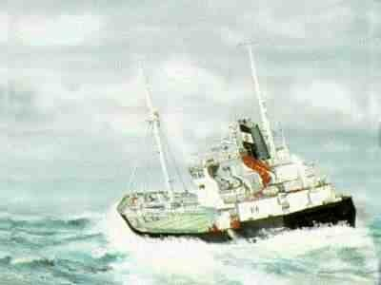
It is the MARPOL conventions that take care of the human safety at sea
There isn't any conventions that take care of the human safety at sea
It is the STCW 78/95 that take care of the human safety at sea
It is the SOLAS conventions that take care of the human safety at sea

254. What are the functions of a flag state administration?
They have responsibility for ensuring that ships are properly registered
The maintain a record of all ship and their crews, and produce statistics involving ships from their country.
They have responsibility for setting, monitoring and enforcing standards of safety and pollution prevention on vessels flying the countries flag
The have responsibility for ensuring that ships are correctly manned and that crews' terms and conditions of employment are met satisfactorily

255. Referring to the SOLAS convention, how often should a crew member on a cargo ship participate in one abandon ship drill and one fire drill?
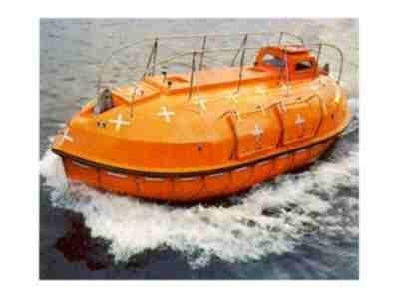
Every second week
Weekly
This is only required when he joins the ship
Monthly

256. The International Maritime Bureau Piracy Reporting Centre attributes the increased numbers of hijackings to:

Easy access to military weapons.
More crew involvement.
The greater involvement in piracy of well-organized and armed crime networks.
Higher crime rates around the world.

257. Which of the following is the minimum acceptable value of insulation resistance for High Voltage equipment?
100 M Ohms
1 G Ohms
100 k Ohms
1 M Ohms

258. What is the maximum current that a 15 Volt, 3 Watt Zenerdiode can handle without damage?
0.5 A
20 A
0.2 A
0.45 A

259. Where is shunt motor normally used?
Where uniform speed is desired regardless of load
Where higher starting torque and varying speed is desired
Where low starting torque is desired
Where varying speed is desired regardless of load

260. A rocket parachute flare reaches an altitude of

not less than 300m
not less than 450m
not less than 180m
not less than 40m

261. Telephones are being used to communicate between personnel onboard and ashore during a bunkering operation. What instruction would you give to ship personnel regarding action to take in the event of failure of the telephone communication during the operation?
Slow down the bunkering rate until alternative reliable communications are established.
Stop the bunkering until alternative reliable communications are established
Use a crewmember as a messenger between personnel involved in the operation.
Call the electrician, and get him to repair the telephone while the bunkering operation continues.

262. What should the expansion valve superheat setting be in order to get the best possible efficiency from a refrigerator evaporator?
minus 18 Celsius
5 - 10 degrees Celsius
25 - 30 degrees Celsius
40 - 50degree Celsius

263. The inductance which will induce an EMF of 1 Volt in a conductor when the current is changing at a rate of 1 Amp per second, is defined as
One milliHenry
One Reactance Unit
One Henry
One Farad

264. When selecting switchgear to work with High Voltage it is important to use an appropriate arc quenching medium. What is meant by arc quenching medium?
Equipment which communicates information about the arcing.
A material which assists a welding process.
The way in which the contacts separate as the switchgear operates.
The gas, liquid or vapour which will minimise creation of an electric arc as contacts open.

265. What is the effect of noise on any electronic system?
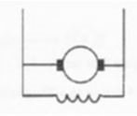
Limits the reliability of the measurement system
Limits the accuracy of the measurement system
Limits the precision of the measurement system
Limits the bandwidth of the measurement system

266. What are the main elements for Process Control?
Sensor, Modulation, Controller, Process
Resistor, Capacitor, Battery, Load
Sensor, Controller, Noise, Final Control Element
Process, Sensor, Final control element and Controller

267. Ordinary thyristors (SCR) must often be protected against reverse overvoltage transients. This is because they can be damaged by over-voltage, even if it is of extremely short duration. These SCRs have been given such over-voltage protection, but only one of them is correct. Which one is it?
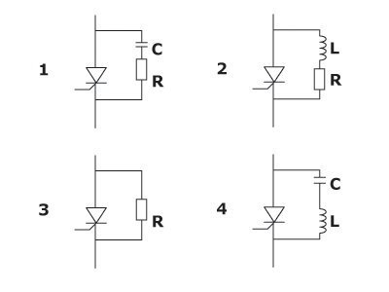
Figure 3
Figure 1
Figure 2
Figure 4

268. A 250V contactor has been fitted to a 220V supply. Which of the following symptoms might be observed?
Contactor overheating
Contactor chattering (vibrating)
Contactor constantly on
Contactor wont operate

269. Master of every ship must provide:

A link between the shipboard training officer and the company training officer ashore
Proper rest to the crew after each training programme
the training during crews working hours only
Facilities to conduct training whenever required by the training officer

270. A two step controller (open/close) has failed and the only available spare controller is a P+I controller. Select, from the options given, how the P+I controller could be set up to achieve approximate two step control.
Set the proportional band to minimum width and the integral action to maximum (repeats per minute).
Set the proportional band to maximum width and the integral action to minimum (repeats per minute).
Set the proportional band to maximum width and the integral action to maximum (repeats per minute).
Set the proportional band to minimum width and the integral action to minimum (repeats per minute).

271. What should you do with the ashes from your vessels incinerator which had burned garbage containing plastics?

Discharge at sea providing you are more than 12 miles offshore
Discharge at sea providing you are more than 25 miles offshore
Discharge at sea providing you are not in any river or estuary
Discharge to a shore facility only

272. Buoyant smoke signals shall be so designed as to burn or emit smoke:

When under water
Only when not in the water
Continuously after having been immersed for a period of 1 minute under 1m of water
Continuously after having been immersed for a period of 10 seconds under 100 mm of water when underwater

273. The range of a transducer is 0-200 bar.and the output signal is 4-20 mA. What is the output signal when the process value is 100 bar?
10 mA
4 mA
24 mA
12 mA

274. The oils used for medium and high speed diesel engine lubrication usually have alkaline additives which give the oil a Total Base Number of about 30 to 40 mg KOH/g. Why is it necessary to have such a TBN for these oils?
To neutralise the acids formed during combustion.
To counteract the effects of fuel leaking into the crankcase.
To increase the load carrying capacity of the oil.
To allow operation of the engine on a variety of fuel types.

275. You can reduce the need for security guards in certain areas by installing:

Vapour detectors
Anti-intruder devices
Water cannons
Metal detectors

276. The image shows an arrangement of electronic components which is often used for a particular reason. What is this type of ciruit usually called?
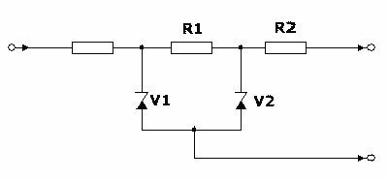
An amplifier
A zener barrier.
A measuring bridge
A rectifier

277. Most medium and high speed engines for marine use operate on the four stroke cycle and use direct admission of compressed air into the cylinders for starting purposes. During which part of the cycle does start air admission normally take place?
The latter part of the expansion stroke.
The first part of the air induction stroke.
The first part of the expansion (power) stroke.
The latter part of the expansion (power) stroke.

278. What is full form of VRP (OPA-90)
Vessel Report Plan
Vessel Reporting Procedures
Vessel Response Plan
Vessel Response Procurement

279. The first step in completing an SSA is to:

Create a list of potential motives for security incidents against your ship.
List the existing security measures.
"Identify the key shipboard operations, systems, areas and personnel that are critical to protect."
Develop an onboard security survey checklist

280. How does the maximum oil film pressure in a white metal journal bearing operating under full fluid film conditions compare with the pressure of the lubricating oil supply system?
The pressure is the same as the pressure in the lubricating system regardless of the journal load.
The pressure is greater than the pressure in the lubricating system and varies with the journal load.
The pressure is less than the pressure in the lubricating system and varies with the journal load.
The pressure is greater than the pressure in the lubrication and is constant regardless of the journal load..

281. The operating mode of a pyrotechnic signal depends essentially on:
The weather conditions of the moment
A definite standard process
The fact that the user is on board a liferaft, a lifeboat or ship
Instructions or diagrams printed on its casing by the manufacturer

282. On an oil tanker, are there any restrictions as to the maximum amount of treated water that originates from cargo spaces that has passed through a bilge water separator that can be discharged?
Maximum is 30 litre pr nautical mile and total is 1/30000 part of full cargo on the ballast voyage.
Maximum is 60 litre pr nautical mile and total is 1/30000 part of full cargo on the ballast voyage.
There isn't any restrictions of pumping sludge from ships outside special areas
Maximum is 30 litre pr nautical mile and total is 1/10000 part of full cargo on the ballast voyage.

283. Which one of the following items has to be included in an abandon ship drill according to SOLAS regulations?

Manoeuvring the lifeboat in the water.
Launching and recovery of a survival craft.
Checking that life-jackets are correctly donned.
Starting and operating radio life-saving appliances.

284. Is it necessary to be certified to be a lifeboat-commander?
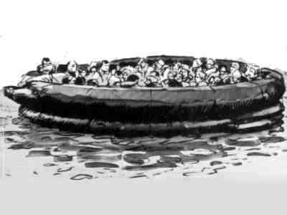
No
Yes, you must attend a one week course at a approved course center.
No, the only thing you need is one hour instruction from a deck officer.
Yes, you must attend to a course held by certified personnel, and provide evidence of having maintained the required standards of competence every five years.

285. Most fuel oil separtors working on the centrifuge principle have an automatic start up and sludging facility. Which of the following actions would you expect to occur first during the start up sequence?
Fuel oil supplied to bowl to fill it.
Operating water drained from bowl to open it.
Operating water supplied to bowl to close it
Sealing water supplied to bowl to prevent carry over.

286. How often should the lifeboat wire falls be turned and renewed?
Renewed every three years
Turned every 30 months and needs only to be renewed if the wire is in poor condition
Turned every 2 years and renewed every 4 years
Turned at intervals of not more than 30 months and renewed every 5 years

287. The fuel injection timing of a diesel engine is delayed causing high cylinder exhaust gas temperatures. What is the likely effect of this condition on turbocharger operation?
Vibration of the turbocharger.
Increased turbocharger revolutions
Continuous surging of the turbocharger
Decreased turbocharger revolutions

288. The charge air pressure supplied to a diesel engine, which is normally 2.0 bar, is reduced to 1.5 bar . What will be the likely effect on the engine operation?
The cylinder cooling water flow will increase.
The turbochargers cooling water flow will increase.
The performance of the engine will be reduced noticeably.
The performance of the engine will be similar to normal conditions.

289. This circuit consists of a current source I, a change-over switch S, a resistor R and a capacitor C. The current/time figures 1 to 4 show possible changes in the current I when the switch S is suddenly shifted from position 1 to 2 at time t= 0. Which diagram is correct?
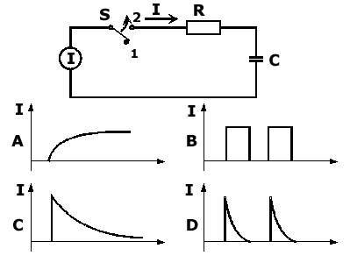
Figure C
Figure D
Figure A
Figure B

290. What kind of electrolyte is used for Nickel-iron batteries?
Solution of potassium hydroxide (KOH) and water
Solution of zinc-carbon and water
Solution of sodium and water
Solution of sulphuric acid and water

291. Which of the following test results obtained using a Digital Multi-Meter shows that a diode in in good working condition?
With + to Anode a reading of about 0.6V and with probes reversed a reading of O/L.
With + to Cathode a reading of about 0.6V and with probes reversed a reading of O/L.
With + to Anode good continuity (low ohms) and with the probes reversed a reading of infinity.
With + to Cathode good continuity (low ohms) and with the probes reversed a reading of infinity.

292. A cable has a resistance of 100 milli-ohms. It supplies a 300A load over a distance of 100 metres. What is the voltage drop along it's length?
30 volts
3.0 volts
300 volts
300 milli-volts

293. What would be the most probable cause if the exhaust gas from a diesel engine looked a bit blue in colour?
Engine burning too much lubricating oil.
Bad fuel oil.
Blocked charge air cooler.
Engine is too cold.

294. In the context of an automated process control system, what is understood by the term Master Controller?
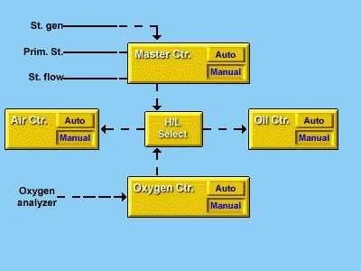
The primary controller in a cascade control system
State of the art controller
The Captain's controller
The best possible control system

295. *Which one of the given requirements regarding manning and supervision of survival craft corresponds to the SOLAS regulation?
A deck officer or certificated person shall be placed in charge of each survival craft to be used
There shall be at least 5 trained persons on board, mustering and assisting untrained persons
Every motorised survival craft shall have a certificated engineer assigned
Every lifeboat required to carry radio telegraph installation shall have a deck officer capable of operating the equipment assigned

296. Who is responsible for keeping the required official publications onboard?
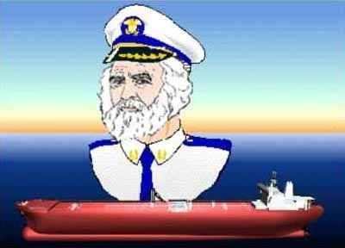
The radio officer.
The master.
The owner.
The authorities.

297. How many Radar Transponders (SART) are required to be carried onboard a ship for use in survival crafts?
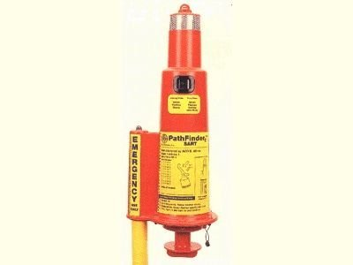
Two on each side of the ship
2, one of which being capable of floating free if the ship sinks
One on each side of the ship
One in each lifeboat

298. The fuel tank contents gauges onboard a vessel are of the air bubble and bell type. The gauges are calibrated for a different fuel type to the actual fuel in the tanks. When correcting the actual contents of the tanks from the gauge readings which of the parameters given in the options is the most important?
Fuel pour point.
Fuel viscosity.
Fuel density.
Fuel temperature.

299. New MARPOL regulations came into effect from July 93 stating that the previous instantaneous rate of discharge of oil content (60 litters per nautical mile) was changed to:
10 litters per nautical mile
30 litters per nautical mile
25 litters per nautical mile
20 litters per nautical mile

300. In which of the following automated control processes will the time constant be of minor importance?
Temperature control
Pressure control
Level control
Flow control

301. What does term "precision" mean?
Nearness to which true value is measured
Average of deviations from the desired outputs tends to zero or is zero itself
An input is repeatedly applied for short time intervals under fixed conditions.
Applied number of occasions where an instrument indicates readings which are very close in value

302. Which of the following prevention actions offers the guarantee of an efficient intervention in an emergency
The installation of protective measures
All the listed answers
Training of the crew
Planning of the emergency

303. When polarity of the incoming power line is reversed, what happens to the D.C. motor?
Motor still rotates in the same direction
Motor explodes
Motor rotates in the reverse direction
Motor stalls

304. Which of the following is true of the reed switch?
Low reliability
High off-resistance
Low offset voltage
Low on-resistance

305. What are the conditions that influence the efforts for organising the fire fighting?
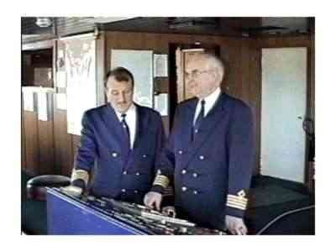
Distance to the fire station and the size of the fire brigade, what is burning, possibility to get water
Where the fire break out, the ships mobility, distance to the fire station and the size of the fire brigade
Where the fire break out, how many fire teams are available, what is burning, distance to the fire station
Where the fire breaks out, how many fire teams are available, the strength of the fire, the ships mobility, what is burning and communication

306. The figures show a graphical symbol for a particular electronic component and a typical working characteristic for the same component. Which component?
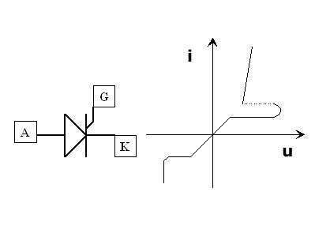
Silicon controlled rectifier (SCR)
Tunnel diode
Field effect transistor
Zener diode

307. What is a Continuous Synopsis Record?

A plan including all security measures onboard
A record of all security incidents
A plan for continuous maintenance of security equipment
A record of the vessels history

308. Give the meaning of the following symbol
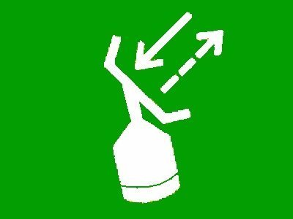
Rocket parachute flares
Radar transponder
Survival craft distress pyrotechnic signals
Epierb

309. Which of the options given is likely to be the reason for a drop in the charge air manifold pressure of a diesel engine operating with an exhaust gas turbocharger?
Exhaust gas boiler fouled.
Insufficient cooling of the charge air.
Scavenge ports dirty.
Engine room exhaust fans stopped..

310. On all UMS operated vessels and also on most other vessels the engine room is equipped with fire detectors. What requirements of testing and checking of the detectors are to be observed?
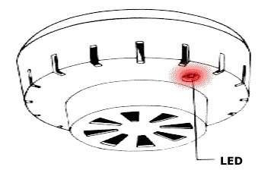
Check that the actual detector is giving appropriate signals to the central control unit and that all electric connections are in good order.
Check the detector with heat and/or smoke (in accordance with instructions in its manual)
When testing detectors by suitable equipment (smoke and heat) check that the sensors self controlling system, e.g. a flashing control light etc. is functioning.
All the mentioned alternatives.

311. What percentage of the ship's stores are required to be inspected at Security Level 3?
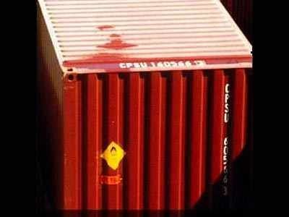
50-80% of the ship's stores are required to be inspected at Security Level 3.
100% of the ship's stores are required to be inspected at Security Level 3.
5-20% of the ship's stores are required to be inspected at Security Level 3.
25-50% of the ship's stores are required to be inspected at Security Level 3.

312. The coil of a 12V, 120mA dc relay must be connected across a 24V supply. What action should be taken?
Install a 100 k ohm resistor in series with the coil
Install a 100 k ohm resistor in parallel with the coil
Install a 100 ohm resistor in series with the coil
Install a 100 ohm resistor in parallel with the coil

313. For a ship operating or calling in US waters, COTP can request (OPA-90)
Maximum one drill a year
Maximum two drills a year
Unannounced drills at any time
Participation in all announced drills

314. Why shall a duly qualified officer supervise any potential polluting operation?
To relieve the master.
To restrict pollution.
To inform the authorities.
To avoid pollution.

315. Which of the following information shall be specified by the muster list?
The abandon ship signal consisting of two long blasts
The muster list has been prepared and approved by the administration before the ship proceeds to sea
The specific duties assigned to passengers that are in charge of a group of others
Action to be taken by crew and passengers

316. To maintain good relationship among the crew on board a vessel, one must be:
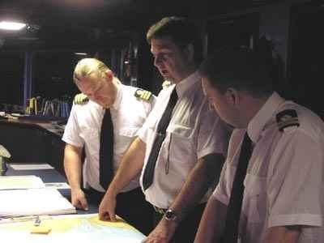
Polite and diplomatic while talking to crew members
Understanding, Co-operative, and have respect from both sides
Strict and authoritative while giving orders
Give authority to others

317. What is the priority for the ship's management team when fire breaks out?
The ship's management team must call the nearest fire brigade and police station
The ship's management team must fight the fire and then call the fire teams
The ship's management team must organise the fire teams and then the teams have to rescue missing personnel
The ship's management team and the crew must evacuate the ship

318. When tuning a cascade control system, which of the following actions should be done first?
Adjust the slave controller with the master controller in manual mode
Adjust both controllers at the same time
Adjust the slave controller with the master controller in auto mode
Adjust the master controller with the slave controller disabled

319. What rules and regulations are regulating the watch keeping routines in the engine room?
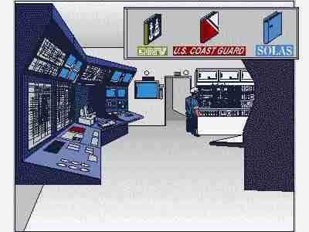
Both STCW and Class rules
Class Rules
International Standard for Training and Watch keeping (STCW)
SOLAS

320. Which of the following is not true of the photo resistor?
High switching rate capability
High on-resistance
Moderate off-resistance
Very low offset voltage

321. Which PPM is allowed for discharging of "Bilge Water" overboard?

100 PPM
50 PPM
15 PPM
0 PPM

322. What is the effect of the I (integration) function of a PID controller?
It will slow down the control system
It will try to reduce the deviation between set-point and process value
Quick control
Easy to change set-point

323. Which of these measures would you implement to prevent drugs from being smuggled onboard your ship while it's berthed?

"Search some of the packages, spares and stores received."
Check a portion of the bags and packages brought onboard.
Eliminate fore and aft deck watch at night.
Maintain restricted areas.

324. Which one of the options given is the most likely cause of a diesel engine failing to turn on air when the start signal is initiated?
Slight leakage at the indicator cocks.
An interlock or blocking device in the remote starting system is operating.
Auxiliary blower is operating.
Start air compressor has cut out due to sufficient pressure in system.

325. The circuit diagrams illustrate four different methods of wiring between a Pt 100 temperature sensor and its signal processing electronics. Which of the wiring methods gives the best measuring accuracy?
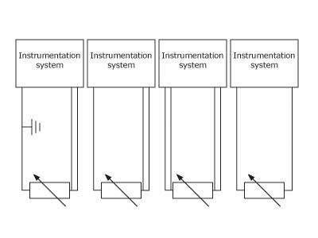
Figure 2
Figure 1
Figure 4
Figure 3

326. Which device does this graphical symbol illustrate?
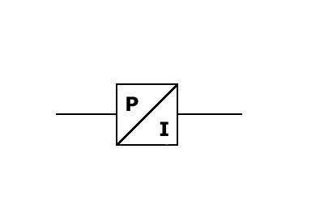
Inverter
Differential pressure transmitter
Pressure to current converter.
Rectifier

327. Which ships does the ISM code apply to
Only tankers and Ro-ros
All passenger ships, all cargo ships of 500GRT or above
All craft above 300GRT
Only passenger vessels

328. A water heating system with automatic temperature control uses steam as the heating medium and the temperature is controlled by a pneumatically operated valve? What would be an acceptable start up procedure of the system from cold state?
Start the system up in automatic mode with normal set point but with the steam supply to the control valve manually throttled in.
Start the system up in manual mode and gradually increase the controller output signal until the temperature reaches the required value before changing over to automatic control.
Start with the control valve in manual and use the hand jack to gradually increase the temperature by throttling the steam flow before changing to pneumatic control.
Start the system up in automatic mode with normal set point so that the required temperature is achieved as quickly as possible.

329. Give the meaning of the following symbol

Line throwing appliance
Survival craft distress pyrotechnic signals
Rocket parachute flares
Parachute landing area

330. Why is it important to have good relationship on-board a vessel?
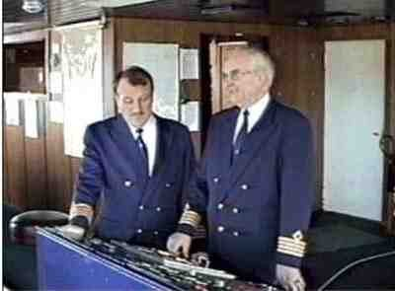
It will prevent accidents from happening
Crew comes to know each others problems
It encourages crew to extend their contract
It leads to better work performance and positive atmosphere among the crew

331. When work must be done on High Voltage equipment, it is vital that the equipment is earthed (grounded) after isolation procedures have been carried out. Why is this so?
To ensure that no energy remains in the system and that it cannot be recharged by external influences.
To ensure that the equipment does not overheat due to currents circulating through earth (ground).
To ensure that it is dead, even if there was a flaw in the isolation procedure.
To provide a reference point, and so ensure accuracy of any test results.

332. Consider a vessel with a 6 cylinder main diesel engine operating with one cylinder out of operation. What would you expect to be the approximate maximum reduced engine load to allow safe emergency operation in this condition?
Approximately 30% of MCR.
Approximately 90 % of MCR
Approximately 50 % of MCR
Approximately 70 % of MCR

333. OPA-90 is referring to a Qualified Individual (QI)
QI is an authorised individual, situated in the US, and contracted by the owner or operator of the vessel
QI is representing the USCG
QI is the owner's contingency leader
An individual certified by USCG to handle oil spills

334. You are on a vessel 10 nautical miles off the coast of Nigeria, West Africa. Are you allowed to dump empty glass bottles overboard ?
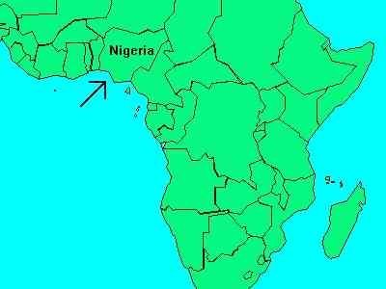
Yes, the bottles can be dumped if they are ground so that the resulting particles can pass through a screen with 50 mm openings
Yes, the bottles can be dumped if they are ground so that the resulting particles can pass through a screen with 25 mm openings
Yes, glass bottles can be dumped overboard
No, glass bottles can not be dumped overboard

335. You are on a vessel 10 nautical miles off the coast of Algeria, in the Mediterranean Sea. Are you allowed to dump food waste overboard?
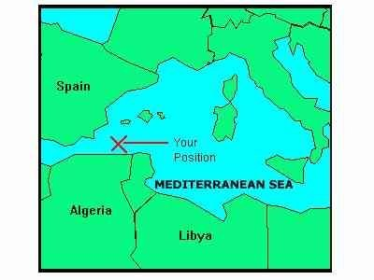
No, food waste can not be dumped overboard
Yes, all kind of food waste can be dumped overboard
Yes, the food waste can be dumped if it is ground so that the resulting particles can pass through a screen with 25 mm openings
Yes, the food waste can be dumped if it is ground so that the resulting particles can pass through a screen with 50 mm openings

336. What is the r.p.m. of a 4-pole motor operating at 60Hz?
3600 r.p.m.
1800 r.p.m.
1500 r.p.m.
1200 r.p.m.

337. What would happen if, when a ship is under-going a Port State Inspection, certificates were invalid or missing
The ship would be allowed to sail to the next port and rectification would take place then
The deficiencies would be recorded in the ship's register and the ship allowed to sail
The ship would be detained indefinitely
Rectification would be required before sailing

338. A Multimeter is not suitable to measure
Resistance
Power
Voltage
Current

339. A voltage measuring instrument has high impedance Zi. If the source impedance, Zg is much lower than Zi, what would be the relative measurement error?
Zg / (Zg + Zi)
Zg / Zi
- Zg / Zi
-Zg / (Zg + Zi)

340. Give the meaning of the following symbol

Parachute landing area
Survival craft distress pyrotechnic signals
Rocket parachute flares
Line throwing appliance

341. Which one of the listed requirements regarding the stowage of a survival craft corresponds to present SOLAS regulations? Each survival craft shall be stowed:
On the starboard side of the ship.
Wherever space is available.
In a state of readiness so that two crew-members can prepare for embarkation and launching in less than 15 minutes.
In a secure and sheltered position and protected from damage by fire or explosion.

342. This circuit shown is a logic gate with two 'high' input signals, A and B, and one output signal Q. Which type of logic function does the gate provide?
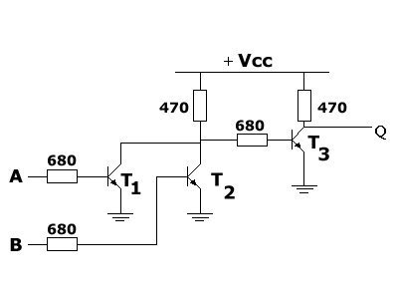
AND gate
NAND gate
OR gate
NOR gate

343. What is the minimum furnace temperature that must be reached during start up before waste material can be introduced into an incinerator?
850 C
1500 C
2000 C
2500 C

344. The Training Manual shall contain instructions and information on the life-saving appliances and the best method of survival. The training manual shall contain detailed explanations of crew duties in relation to emergency situations. Which of the following tasks or duties shall be included in the manual according to present regulations?

The use of escape routes and other escape methodes.
The use of surface to air visual signals to be used by survivors.
The use of navigational equipment for survival crafts.
The use of the ship's line throwing apparatus.

345. This graphical symbol is a logic gate. Which type of logic function does the gate provide?
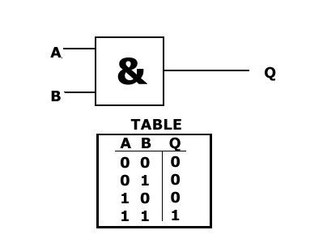
OR
AND
NOR
NAND

346. What type of bomb search should you conduct to avoid panic when the credibility of the threat is in doubt and you don't want to disrupt ship business?
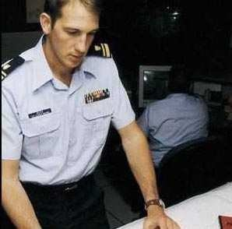
External search team
Crew search
Known hiding spot search
Nominated officers search

347. What should be the healthy continuity resistance of a 220V, 2.2kW,10A heating element, when checked near to it's rated operating temperature?
10 Ohms
220 Ohms
0.1 Ohms
22 Ohms

348. On board passenger ships an abandon ship drill must be performed:
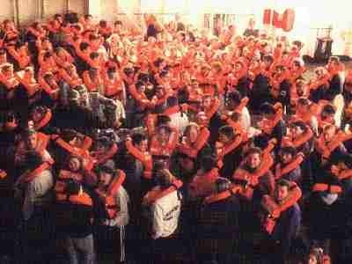
Every month
Every two weeks
Every week
Every three months

349. Which organization or administration is responsible for surveys and inspections of ships, and the issue of Safety Certificates?
International Maritime Organization (IMO)
International Labor Organization (ILO)
Ships Classification Associations (Lloyd's, American Bureau of Shipping, The Norwegian Veritas, Germanische Lloyd's, etc.)
Government Authorities of the Flag State

350. Small oil spills on deck can be kept from going overboard by doing what?
Plugging the sounding pipes
Driving wooden plugs into the vents
Plugging the scuppers
Closing the lids on the vents

351. Which of the following items must be included in each fire drill?
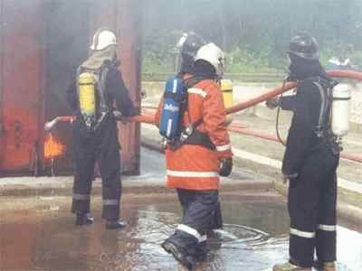
Starting a fire pump using at least two required jets of water to show that the system is in proper working order
Checking fireman's outfits and other personal rescue equipment
All the items mentioned
Reporting to stations and preparing for the duties described in the muster list

352. The training manual shall contain instructions and information in easily understood terms and illustrated wherever possible. Which of the following objects have to be explained in detail in the manual according to present regulations?
Donning of fire protection clothing
Starting of Main Engine
Donning of lifejackets and immersion suits
Handling of stowaways

353. What is the function of dynamic braking in fast moving motor?
Protect the motor from getting damaged by friction brake
Slowing down the motor
Stop the motor
Momentarily slows down a motor before speeding up when dynamic braking is released

354. "A contractor is hired to install new navigation equipment onboard your ship while it's berthed. For a period of time he's left unsupervised and photographs schematics of the ship that he finds rolled up and stored in the corner of a nearby office. Later, from home, he hacks into the network and prints off information about the ship's security procedures. Which of these information security measures would have prevented his unauthorized access?"
"Secure area, passwords, a firewall and a secure network."
"Firewall, protective markings, vetting and a secure network."
"Protective markings, reference checks, and passwords."
"Secure area, passwords, a firewall and protective markings."

355. Which one of the following is not a requirement of an emergency generator used onboard ship?
Started automatically upon failure of main source of electrical power supply
Connected automatically when first main generator is overloaded
Driven by prime mover with an independent supply of fuel
Connected automatically to the emergency switchboard in not more than 45 second

356. Only search vehicle compartments where you suspect objects may be hidden.
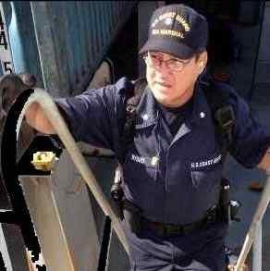
TRUE
FALSE
.
.

357. Give the meaning of the following symbol

Radar transponder
Rocket parachute flares
Survival craft distress pyrotechnic signals
Epierb

358. What is the main theme of modern safety practice?
Making use of Risk Assessment as a means to improving safety
Health & Safety at Work Act
Consult the chief officer before commencing work
Use the same practice that has been in place for some time

359. Continuity testing of a delta connected three phase induction motor yields the following results; U-V =3 ohms, V-W =3 ohms, W-U =6 ohms.Which of the following is the likely condition?
Partial fault between W and U
Open circuit winding between W and U
Short circuit between V and Earth
Short circuit winding between W and U

360. What is the best way to avoid pollution from small oil-spills aboard a ship?
Have dispersing chemicals ready for use in case of oil-spill
Contain any oil-spill onboard the ship
Have sawdust ready for use
Rig an oil boom around the ship

361. From the options given, select the one which is most likely to result in a high exhaust temperature in one cylinder of a diesel engine.
Speed governor defective.
Compression pressure too low.
Nozzle ring of turbocharger fouled or partially choked.
Scavenge ports of the one cylinder are dirty.

362. Medium and high speed diesel engines used for electrical generation duties on board ship have overspeed protection devices fitted to protect the engine in case the electrical generator trips while carrying high loads. Why are these devices necessary?
To stop the engine before any serious damage occurs due to excess inertial loads.
To stop the engine before any serious damage occurs due to rapidly changing cylinder pressures.
To stop the engine before any serious damage occurs due to rapidly changing thermal loads.
To stop the engine before any serious damage occurs to the electrical components due to excess voltage and frequency.

363. Which of the telecommunication equipment does not require 18 hours of emergency power during main power failure?
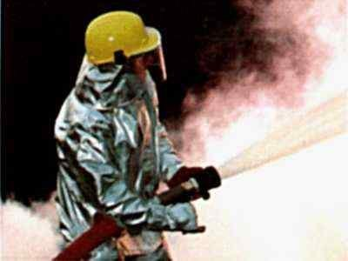
Gyro compass
Radar
Magnetic compass
LAN network system

364. Which personnel must undergo familiarization training on board
Only the deck officers
Only the ratings
Only catering staff
Everyone

365. Which of the following classified equipment is not allowed to be installed in a Zone 1 hazardous area?
Ex n
Ex d
Ex m
Ex p

366. How do you change the below earth neutral system into an isolated neutral system?
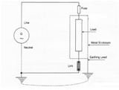
Remove all earthing lead
Replace link with fuse
Cannot be done
Remove earth on generator neutral

367. Which one of the listed requirements regarding the stowage of lifeboats and life-rafts corresponds to present SOLAS regulations?
Life-rafts intended for throw-overboard launching shall be stowed midships secured to means for transfer to either side.
Davit-launched life-rafts shall be stowed on starboard side of the ship.
Life-rafts shall be stowed close to the stern of the vessel
Lifeboats shall be stowed attached to launching appliances.

368. A ship's power system operates at 60Hz but when connected to shore supply it is supplied with 50Hz. Which of the following would you expect?
Earth faults are more likely.
Electric motors will run at reduced speed and will tend to overload the magnetic structure of motor.
Electric motors will run at increased speed and will tend to overload the magnetic structure of motor.
Generators are more sensitive to reverse power faults.

369. Which one of the listed requirements regarding abandon ship drills corresponds to present SOLAS regulation?
Drills shall be conducted when the ship is in a harbour
Each lifeboat shall be launched, and maneuvered in the water with its assigned crew at least once every three months during an abandon ship drill
On ships on short international voyages, each lifeboat shall be launched and maneuvered in the water at least every six months
All lifeboats shall be lowered during drills

370. A low exhaust temperature in one cylinder of a diesel engine is noticed during routine checks. Which of the options given is the most likely cause of this?
Some of the nozzle holes of the fuel injection valve are blocked.
Injection valve opening pressure is too low.
Charge air pressure is too high.
Problem with the fuel quality or supply to the engine.

371. Which of the following conditions could result in the exhaust from a diesel engine being dark coloured?
Fuel injection pump timing too advanced.
Water in the fuel.
Low charge air temperature.
Some or all of the cylinders overloaded.

372. An Oil Record Book, Part 1,shall be provided to every ship of 400 tons gross tonnage and above to record machinery space operations.Out of below mentioned operations, it is compulsory to record:
Discharge of water from Aft, Peak Tank.
Transfer of oil from settling - to daytank.
Bunkering of bulk lubricating oil.
Purification of HFO.

373. The pressure in the fresh water cooling system for a diesel engine is fluctuating while the engine is running. When the engine is stopped the pressure is steady. What is the likely cause of this problem?
The fresh water expansion tank is empty.
The temperature in the fresh water cooling system is too low.
The engine has a cracked cylinder liner or cylinder cover.
The fresh water circulating pump is damaged.

374. What does the term DISCHARGE mean, as used in the Oil Pollution Regulations?

Dumping
Spilling
Leaking
All the other alternatives

375. In which of these circumstances can your ship request a DoS?

Your ship is operating at a lower security level than the ship or port it is interfacing with.
Your ship has added a new port to its list of ports of call.
There is a heightened security risk for your ship and a port facility.
Your ship is conducting activities with a port or ship that is not required to implement an approved security plan.

376. Thermo-elements will typically have
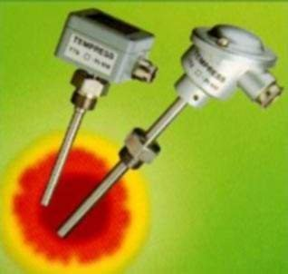
Relatively wide range of temperature measurement
No influence at all on the readings
A tendency to load the instrumentation system
Relatively narrow range of temperature measurement

377. Who is responsible for completing the DoS on behalf of the ship?
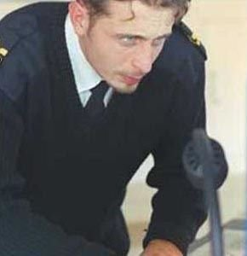
Company Security Officer
Chief Engineer
Ship Security Officer
Chief Officer

378. What does the abbreviation SOLAS mean?
International Convention for the Safety of Lives at Sea
International Agreement for Security of Load and Ships
International Conference for Security of Loads aboard Ships
International Rules for Safe Ocean Lines and Sailingroutes

379. What is the status of the rules of the SOLAS convention?
Should be consulted when the vessel is in distress.
Must be regarded as guidelines.
Mandatory.
Supplementary to classification rules.

380. Which of the following would be considered pollution, when discharged overboard, under the US water pollution laws?
Hazardous substances
Oil
Garbage
All of the mentioned

381. For which of the following ships, is the MARPOL convention applicable?
For all vessels except passenger vessels.
For tankers and other vessels carrying persistent oil as cargo.
For all listed vessels.
For all vessels except those engaged in coastal trade.

382. Give the meaning of the following symbol
EPIRB
Survival craft portable radio
Rocket parachute flare
Survival craft distress pyrotechnic signals

383. When measuring viscosity with a restricted flow viscometer, the preferred sensing device is:
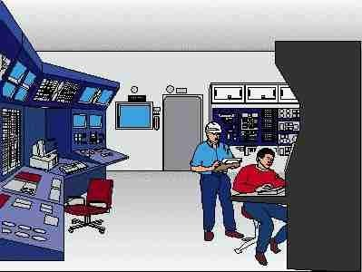
Bourdon tube
Capacitance probe
Capillary tube
Rotating cylinder

384. Some automated control systems use a master controller and a slave controller. What is the meaning of "remote mode" in relations to a slave controller?
The slave controller can be tuned from the engine control room
The slave controller can be tuned by a hand carried remote controller
The slave controller receives the set-point from the output signal of the master controller
The slave controller can be in any mode of operation

385. A vessel is installed with Power Management System (PMS). If there is an increase overload or fault in a running generator, what will the PMS do?
It will shut down auxiliaries system in the emergency switchboard
It will activate the Public Alarm system and shut down the generator instantly
It will activate the emergency generator to share load or take over load of the faulty generator
It will automatically start the next generator in the start sequence

386. The main propulsion diesel engine is normally started by direct admission of compressed air. Which one of the following statements is correct?
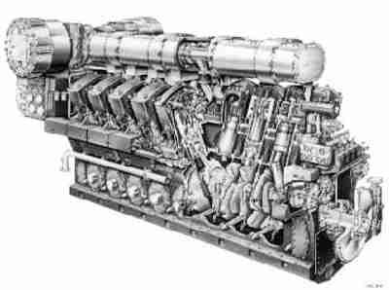
If the starting air pressure is too low a pressurized oxygen bottle from the welding equipment can be used for an emergency start of the engine.
A heavily leaking starting air valve may cause an explosion in the starting air pipe system.
The starting air admission should continue until the engine has fired.
If the engine does not turn when the starting air is applied the turning gear can be used together with the starting air to start the engine.

387. What type of D.C. motor is below diagram showing?
Series wound
Shunt wound
Compound-wound
Separately-excited

388. One of the categories of information that must be included in your SSP is:

Security arrangements
Threat scenarios
Ship security survey
Weaknesses in security measures

389. Where do you find minimum drill requirements?
In classification society rules
In manager's instructions
In the SOLAS convention and its annex
In owner's instruction

390. In terms of an automated control system, what is meant by the expression ''Slave Controller?
The controller is always working hard
The controller is following a pre-set control sequence
Feed water controller
The secondary controller in a cascade control system

391. A diesel engine is operating with retarded fuel timing resulting in increased exhaust gas temperatures. How would you expect this to affect the turbocharger?
Decreased turbocharger revolutions.
The turbocharger would operate normally.
Increased turbocharger revolutions.
Reduced air and gas temperature after turbocharger.

392. Which statement(s) is true of a gasoline spill?
It will sink more rapidly than crude oil
It is visible for a shorter time than a fuel oil spill
It does little harm to marine life
It is not covered by the pollution law

393. Temperature sensors of all types are normally mounted in a well, or pocket, when used in pipelines. Why is this done?
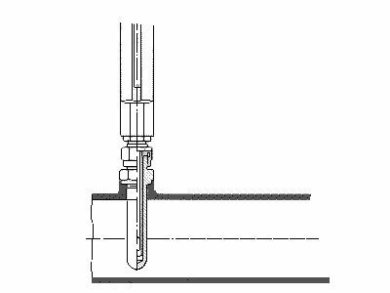
Suppress electro-magnetic interference between liquid in the pipe and the sensor.
Avoid electric current flowing from the sensor to the liquid.
Allow removal of the sensor also when liquid is flowing in the pipe.
Decrease the temperature gradient between the liquid and the sensor.

394. A Ship Security Assessment is integral to the creation of your ship's security plan.
TRUE
.
.
FALSE

395. Temperature sensors may be marked PT100. What does this mean?
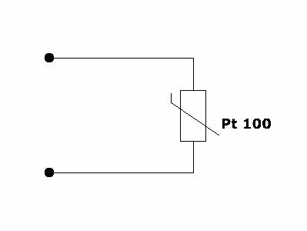
100 ohm at 20° C
20 ohm at 100° C
100 ohm at 0° C
0 ohm at 100° C

396. For what period of time is the protection and environment committee elected?
3 - 4 years.
8 years.
5 - 6 years.
1 - 2 years.

397. How many annexes do we find in MARPOL and what is the content of annex 1?
We find 5 annexes in MARPOL and annex 1 is the regulations for the prevention of pollution by sewage
We find 1 annexes in MARPOL and annex 1 regulations for the prevention of pollution by chemicals.
We find 4 annexes in MARPOL and annex 1 regulations for the prevention of pollution by garbage
We find 6 annexes in MARPOL and annex 1 is the regulations for the prevention of pollution by oil

398. What is the valve status as shown below?
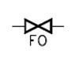
Valve is filled with fuel oil
Valve is overfilled with fuel oil
Fuel oil valve
Valve fails to open

399. Which of the following duties shall be included in the "muster list" as being assigned to crewmembers in relation to passengers?
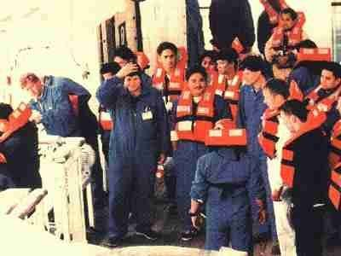
Ensuring that extra food and water is taken to the survival craft
Clearing the escape routes
Ensuring that every passenger is provided with an immersion suit or a thermal protective aid
Assembling passengers at muster station

400. A motor nameplate reads 75 hp. What is the reading in kW?
37.5kW
128kW
56kW
75kW

401. Some process control systems may have several inputs and controlled variables. In this context what is meant by split-range?
Several controllers are connected to the same control-valve
Several control-loops for the same range
Several control-valves are connected to the same controller
On-Off control

402. The turbocharger on a diesel engine is surging. Which one of the following options would be the most likely cause?
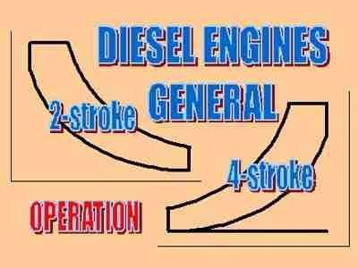
Dirty scavenging air cooler on the air side
Dirty rotor blades and nozzle ring.
Worn out bearings on the turbocharger
The lubrication oil pump is malfunctioning

403. Which electronic component or system is this graphical symbol illustrating:
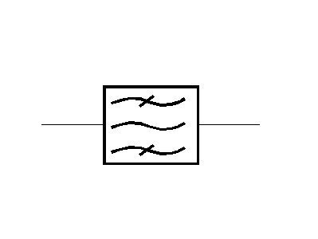
Transformer with ferromagnetic core
3-phase sine-wave generator
Electric heater
Bandpass filter

404. What is an earth fault?
It is a break in the insulation, allowing the conductor to touch the hull.
It is a trip in the MCB.
It is a double break in insulation of two conductor of different potential, allowing a large current to pass through.
It is a break in the conductor, not allowing current to pass through.

405. "Part way through a profiling interview with a supplier, the package the individual is carrying arouses your suspicion. What do you do?"

Call for help on the radio.
Take the package and open it.
Discreetly inform someone of your suspicions so he or she can get assistance.
Confront the individual and demand that he open the package.

406. MARPOL - Annex IV. Prevention of Pollution by Sewage from ships. What do you understand by the word "Sewage"?
Mixture of sea water/oil.
Waste from galley.
Drainage/waste from toilets/urinals.
Waste from synthetic materials.

407. What is the function of space heaters inside alternators?
To give more space for air flow to cool the generator
To prevent internal condensation from forming on the winding insulation during non-operation
To maintain alternator's temperature during operation
To prevent insects and rats from coming into generator during non-operation

408. Which of the following items shall be included in an "abandon ship"-drill?
Checking that passengers and crew are suitably dressed and lifejackets correctly donned
Checking that all crew and passenger moral is high
Checking the distress signal rockets and other distress signals
Checking the lifeboat provisions and supplies

409. In a distress situation, how many times or for how long should the emergency alarm signal be sounded?
Until all crew members and passengers have reported to their respective muster stations
3 times
3 minutes
Until the signal "risk is over" or the order "abandon ship" is given

410. How often are "abandon ship" drills required to be held on cargo vessels according to SOLAS?
Once every 6 months.
Once every week.
Once every year.
Once every month.

411. Which one of the following is not an electronic switch?
MOSFET
Thermocouple
Thyristor
Bipolar

412. One cylinder of a diesel engine has to be cut out to allow continued operation of the engine. Which of the following options may be the cause of the problem?
Low charge air pressure.
Gas side of turbocharger fouled.
Camshaft timing incorrect.
Injection pump failure.

413. Who is responsible for issuing an ISPS certificate?
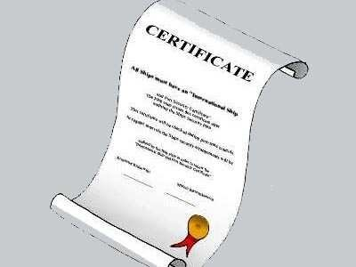
The Port State
The insurance company
US Coast Guard
The Flag State

414. During operation of the main engine, the exhaust temperature increases on one of the cylinders. The turbocharger starts surging and smoke is seen coming out from the turbocharger inlet air filter. What is the most probable cause?
Turbocharger failure.
High back pressure in the exhaust system after the turbocharger.
A fuel valve is stuck in the open position.
Scavenge box fire

415. Which of the following is an application of an inductive sensor?
Strain gauge
Tachometer
Salinometer
Barometer

416. What should be the status of the suction and discharge valves when starting a centrifugal pump?
Suction valve closed and discharge valve open
Suction valve open and discharge valve closed
Both valves closed
Both valves open

417. "If drugs or suspected drugs are found onboard your ship, follow the five C's. Confirm, Clear, Cordon, Control and:"
Check
Change
Chuck
Cheer

418. You are taking fuel on your vessel in the US when you notice oil on the water around your vessel. You are to stop taking fuel and:
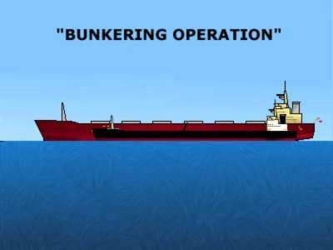
Notify the Corps of Engineers
Notify the US Coast Guard
Leave the area
Begin clean up operations

419. What is definition on clean ballast as per MARPOL Annex 1?
Ballast with an oil content of less than 1 %
There isn't any definition on clean ballast
Ballast with an oil content of less than 45 ppm
Ballast with an oil content of less than 15 ppm

420. What is the period of validity of the Safety Management Certificate
2 years
1 Year
6 months
5 years

421. When considering instrumentation systems, what is a typical symptom of a fault with the span of an instrument?
100% output is accurate, but Zero-point is wrong
Linearity problems
Zero-point and 100% are correct, but not at mid - range
Zero-point is accurate, but 100% input is not giving 100% output

422. When measuring level of liquids with a conductivity level indicator, meaurement is performed by?:
Electrodes
Displacement probe
Capacitance probe
Ionization chamber

423. What must be done if the Oil Discharge Monitoring Equipment (ODME) should fail during a ballast voyage?

All of the mentioned must be performed
The failure must be noted in the Oil Record Book
The failure must be repaired
If the failure cannot be repaired onboard, the ODME must be repaired before the ship commences its next voyage

424. The DoS addresses the responsibility for the security of the water around the ship and the verification of increased threat levels.
TRUE
FALSE
.
.

425. What is the function of a reference cell in a Impressed Current Cathodic Protection (ICCP) system?
Records daily measurement logs
Measures the value of galvanic voltage with hull material
Facilitate monitoring of voltage of controller
Discharges voltage to deter marine growth on the hull

426. A compressed air supply system has two automatically controlled air compressors. When demand is high both compressors are needed to meet the delivery requirements. What is the best method for controlling the compressors to meet a varying, but intermittent demand?
One compressor running continuously with the other on standby.
Sequential start initiated by pressure switches set at different switching pressures.
Continuous running of both compressors and the use of unloading devices.
Start and stop of the compressors controlled by timer switches.

427. The figure shows a silicon controlled rectifier with a RC circuit connected in parallel. What is the purpose of the RC circuit ?
Protect the SCR against damage caused by fast high voltage spikes
Provide a controlled time delay for the SCR trigger pulse.
Measuring the current through the SCR
Obtain current resonance

428. Assign men to search men and women to search women unless a device such as a metal detector is used.
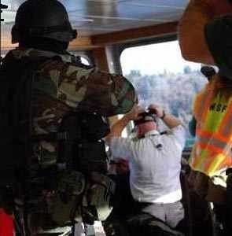
TRUE
FALSE
.
.

429. What type of valve is below picture showing?
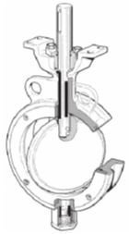
Plug valve
Diaphraagm valve
Butterfly valve
Ball valve

430. Which of the following is not an indication of a fully charged battery cell?
Gassing at the anode and cathode
Constant voltage of the cell with small tolerance
Deep chocolate brown for anode and clear slate-grey for cathode
Low density of electrolyte

431. MARPOL - Annex V. Disposal of garbage outside "Special Areas". After unpacking spares, you are left with a limited amount of packing materials. Is this prohibited, if not, what will be the nearest distance to land for disposal into the sea of these materials?
25 miles
12 miles
This is prohibited
3 miles

432. During abandon ship exercise, what life-saving equipment must be demonstrated?
Location of immersion suits and thermal protective aids
Wearing and fastening of lifejackets and associated equipment
Lifeboat radio
How to communicate using the hand-held radios

433. When starting three phase induction motors there is sometimes a need to use a star-delta starter. Which of the following characteristics does a star-delta starter exhibits while connected in star?
Reduced current and increased voltage
Increased current and power
Reduced current and reduced torque
Reduced current and increased speed

434. Which of the following is not part of control valve assembly?
Positioner
Valve body
Sensor
Actuator

435. What is most important for crew members when preparing for emergencies?
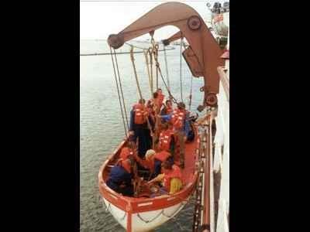
That people know where to muster
That people know where to find designated equipment
That people are well trained
That people listen to orders given

436. Which of the following measures is to be taken when working with batteries?
Keep the batteries in discharged state
Add new acid electrolyte to batteries that are in use
Recharge batteries immediately after discharge
Install alkaline and lead-acid batteries in the same compartment

437. Give the meaning of the following symbol
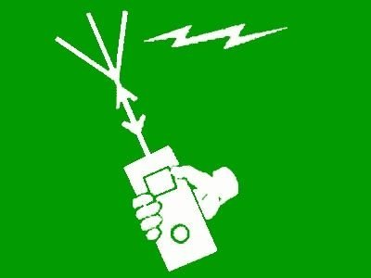
Survival craft portable radio
EPIRB
Rocket parachute flares
Survival craft distress pyrotechnic signals

438. If drugs are discovered onboard your ship....

Ensure the witness to the discovery signs your incident report.
Write a report a few days after the event and describe everything that occurred.
Disembark crew and passengers as quickly as possible at the next port of call so the authorities can conduct their investigation.
Notify the authorities after you arrive at the next port of call.

439. During helicopter evacuation of an injured man, what course should the ship steer?
With the wind fine on the bow opposite to the helicopter operating area
With the wind astern so that the effect of the wind is reduced as much as possible
Directly into the wind
As instructed by the helicopter pilot

440. Following shows circuitry of a peak detector. What is the output voltage curve, Vo if Vi is a sinusoidal input curve?
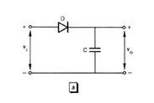
Vo will be the same sinusoidal curve but at a lesser amplitude.
Vo will spike when Vi is at the maximum / minimum point of the sinusoidal curve; zero everywhere else
Vo will peak when Vi is at the maximum, remain constant and fall to zero when Vi becomes negative
Vo will peak at a level less than Vi maximum voltage and remain constant throughout

441. During inspection of the crank bearing for one of the units in the main engine, the bearing shell was found as follows: Surface of the white metal was black and very hard. Patches of black incrustations have worn grooves in the journal. What is the likely cause of this condition?
Bearing shell service time exceeded.
Water present in the lubricating oil during service.
Poor casting of bearing shell white metal lining.
Dirt particles in the lubricating oil during service.

442. On the basis of their conductivity, materials can be classified as isolators, semiconductors or conductors. Which of the following is considered a conductor?
Germanium
Silicon
Phosphor
Copper

443. What is the effect of high operating temperature on insulation resistance of equipment?
No effect
Insulation resistance reduces
Insulation resistance increases
Insulation resistance increases then drops

444. *Which of the following detailed explanations should be mentioned in the Training Manual ?
How to use surface to air visual signals to be used by survivors
How to use navigational equipment for survival crafts
How to use escape routes and other escape methods
How to recover survival craft and rescue boats including stowage and securing

445. In which areas is plastic material accepted for overboard disposal?
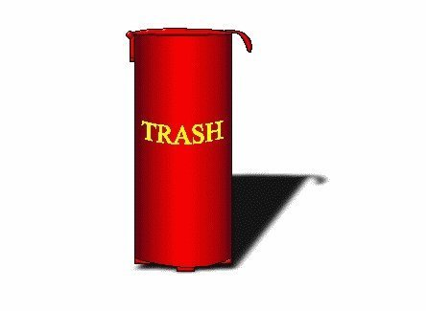
Not permissible any where.
100 n.m. from shore line.
In specially designated areas (ref. MARPOL).
In coastal waters.

446. What function is this circuit performing?
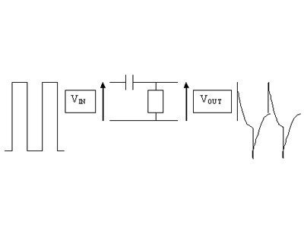
Integrating
Telemetering
Differentiating
Modulating

447. In fresh water tank we are using a pressure transmitter with a range of 0-0.5 bar/4-20mA for level measurement. The transmitter is installed 30 centimetres from the bottom of the tank, and the tank is 5 meters high. What will the output from the transmitter be when the tank is empty?
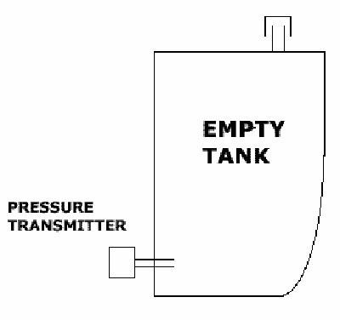
2,8 mA.
5,2 mA.
2 mA
4 mA.

448. For how long time must the printout from the Oil Discharge Monitoring Equipment (ODME) be retained onboard?

Two years
Six months
Four years
Three years

449. If pollution takes place, what would you do immediately?
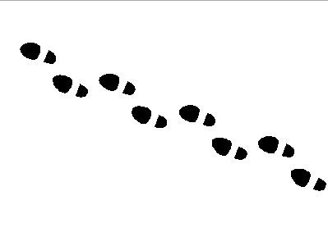
Report to relevant authorities.
Inform the vessel's agent.
Inform the manager.
Start clean-up operations.

450. Which type of temperature sensor is used in this temperature measuring system shown?
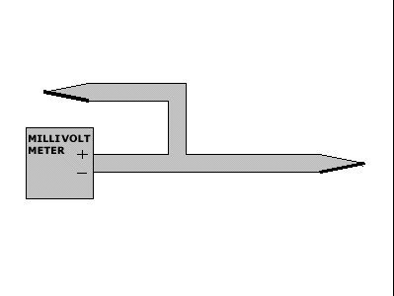
Platinum resistance sensor
Thermocouple sensor
Quartz sensor
Thermistor sensor

451. This amplifier circuit is a common configuration used to amplify the difference in voltage between two input signals. In this case it is input 1 and 2. What is this amplifier called?
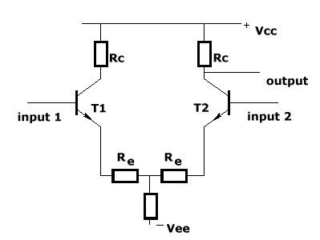
Push-pull amplifier
Differential amplifier
Darlington connection amplifier
Common emitter amplifier

452. *As far as human factor is concerned, which of the following actions should be considered as an efficient one?
To establish inner rules to perform work of a special risk
To equip them with better communication systems
To train the fire brigade
All the listed answers

453. "Your ship security plan must include procedures for responding to security threats, auditing security activities and interfacing with the port facility."
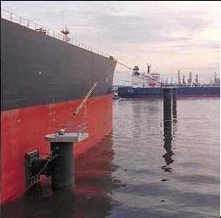
.
.
TRUE
FALSE

454. What does STCW deal with?

STCW deals with training centre and schools and standards for watch keepers
STCW deals with minimum recommendation for training centre and schools
STCW deals with minimum recommendation of education for seafarers and minimum standards for training centre and schools
STCW deals with recommendation for training centre and schools and type of education for seafarers

455. What type of D.C. motor is below diagram showing?
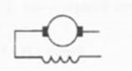
Series wound
Shunt wound
Compound-wound
Separately-excited

456. What percentage of the baggage is required to be checked at Security Level 1?

25-50% of the baggage is required to be checked at Security Level 1.
5-15% of the baggage is required to be checked at Security Level 1.
100% of the baggage is required to be checked at Security Level 1.
The percentage is not specified.

457. What is the alcohol content in the blood permissible under US legislation before it is defined as intoxication?

0,04 %
0,01 %
0,07 %
0,1 %

458. What size is a kilobyte?
10000 bytes
1024 bytes
1000 bytes
16 bytes

459. When two alternators are operating in parallel and field current of the second alternator is increased, which of the following is not observed?
System terminal voltage is increased
Apparent power supplied by first alternator is increased
Reactive power supplied by first alternator is decreased
Reactive power supplied by second alternator is increased

460. Who is responsible for the development of the Ship Security Plan?
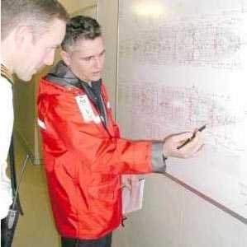
The Port Facility Security Officer
The Ship Security Officer
The Company Security Officer
The Classification Society.

461. The analyses of the smoke produced by a fire, may give an interpretation of that fire. Which are the factors we should take into account?
There is no possible interpretation of a fire according to the smoke
Colour only
Opacity, amount and colour
Amount and opacity only

462. Records relating to breaches of security and changes in security level must be secured against unauthorized access and available for review by contracting governments.

.
FALSE
.
TRUE

463. Identify symbol shown below.
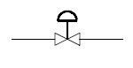
Solenoid
Spring
Motor
Diaphragm

464. Three earth lamps indicate (under no test mode) - bright - bright - dark. Which of the following is indicated by this condition?
Two phases are good and one has a hard fault to earth
Two phases have a partial fault to earth and one is good
A failed lamp
Two phases are good and one has a partial fault to earth

465. Who is responsible for the regular security inspections of the ship?

The Company Security Officer
The Ship Security Officer
The Port Facility Security Officer
The Classification Society.

466. Which IMO convention takes care of the human safety at sea ?
the STCW 78/95
there isn't any conventions that take care of the human safety at sea
the MARPOL convention
The SOLAS convention

467. When a pollution incident occurs there is a plan for actions to be undertaken. State which of following priority sequences to be considered:
Stop pumps - clean up - report?
Report - stop pumps - clean up?
Clean up - report - stop pumps?
Stop pumps - report - clean up?

468. What is a contingency plan for ships?
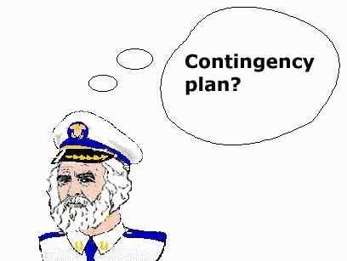
Plan for next voyage
Loading plan for general cargo
Plan for maintenance and repair
Plan for safety preparedness

469. What is the skin effect?
Current that occurs in motors where there is relative motion between the armature of the motor and magnetic field from the motor's winding
Reduction in governor's reference speed as fuel position increases
Current concentrating at parts of a conductor where back e.m.f. is minimum, increasing resistance and thus losses
Chemical process in which a substance loses or gains electrons

470. The best way to prevent stowaways from boarding your ship is to:
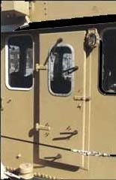
"Seal spaces that are not in use while in port, and perform a search of the ship before leaving."
Search the ship when you arrive at port and again just after leaving.
"Conduct routine, but irregular searches of the ship."
Conduct a Nominated Officers search.

471. The best way to ensure you get the equipment you need is to:

Buy what everyone else is buying.
Buy the newest models.
Buy the most expensive equipment on the market.
Determine your needs and do some research.

472. Temperature sensors may be marked T 802. What does this mean?
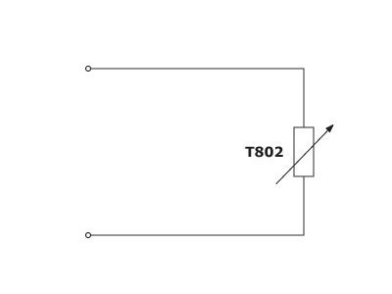
20 ohm at 100° C
802 ohm at 20° C
100 ohm at 20° C
20 ohm at 802° C

473. Shipboard Emergency Drills must be carried out at least (OPA-90):
Once a week
Once every six months
Once a year
Once a month

474. Where should the placard you are shown be located, according to U.S. Coast Guard regulations ? (Title 33-Navigation and Navigable waters, § 155.440 )
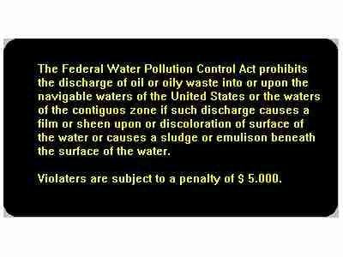
In the wheelhouse
Both in a conspicuous place in each machinery space and in a conspicuous place at the bilge and ballast pump control station
In a conspicuous place in each machinery space
In a conspicuous place at the bilge and ballast pump control station

475. MARPOL - Annex I. Your vessel sailed from Bahrain heading for Singapore. 2 days after departure, you would like to empty your machinery space bilges. What will be the correct procedures in this connection?
Call the bridge and request for position and permission to discharge overboard through oily water separating and filtering equipment.
Discharge overboard through oily-water separating and filtering equipment without calling the bridge.
Call the bridge and request for position and permission to discharge directly overboard.
Wait till after darkness and discharge in most convenient way.

476. With respect to the ISM, what training in addition to lifeboat and fire drills must be carried out?
Mooring operations
The boat drill and fire drill should be adequate to meet your needs
Familiarization, and other drills identified as necessary by the ship
Bridge Team Management

477. The wheatstone resistance bridge is often used for measuring resistances in, forexample, Pt 100 temperature sensors or strain gauges. This figure shows such a bridge. Under what conditions will the bridge be balanced? i.e. the current through the meter i(m) = 0.
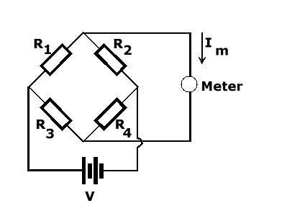
R1 / R2 = R3 / R4
R1 / R4 = R2 / R3
R1 * R3 = R2 * R4
R1+ R3 = R2+ R4

478. Which of the following is not normally used as a main switchboard incoming circuit breaker?
Miniature circuit breaker (MCB)
Oil circuit breaker (OCB)
Air circuit breaker (ACB)
Vacuum circuit breaker (VCB)

479. The picture shows the component parts of a fluorescent light (items 10 to 14) above a circuit diagram (items 1 to 9). Between which terminals of the circuit should the ballast (or choke) be connected?
1 and 2
5 and 6
3 and 4
1 and 9

480. Which of these statements about drug smugglers modes of operating is true?

Drugs hidden by individual entrepreneurs are usually difficult to detect.
"Drugs smuggled by an organized conspiracy are usually concealed in a primary ship system such as the engine room or in a tank, void or compartment."
Individual entrepreneurs usually smuggle large quantities of drugs.
An organized conspiracy usually smuggles a small amount of drugs.

481. What would be the preferred colour to use when maintaining the paint on shell, plating, structure and bottom/tanktopp in the engine room?

White or light grey to ensure all minor spills and leakages are noticed and dealt with.
Dark brown/red colour to camuflage any minor leakages and oil spills.
The same colour as machinery and equipment.
Whatever paint is available.

482. Which international convention deals with pollution prevention?
MARPOL.
SOLAS.
STCW.
ISGOTT.

483. What is the advantage of a transmitter with a narrow measurement range?
Easy installation
Do not need any calibration
Lower purchase cost
Better linearity and increased accuracy

484. What is the function of a compounding Control Automatic Voltage Regulator (AVR) in generator excitation?
To maintain prime driver speed of generator
To trim down current to correct value
To increase electromagnetic field to acceptable range
To increase current to correct value

485. Who is responsible for ensuring your ship completes a security assessment?
Recognized Security Organization
Company Security Officer
Ship Security Officer
Flag State Administration

486. Who is the leader of the lifeboat drill (abandon ship drill)?
The first member of the crew arriving at the survival craft.
Sen.Off.Engine.
The appointed lifeboat commander.
Sen.Off.Deck.

487. Any ship of 10.000 tons gross tonnage and above shall be fitted with oily-water separating equipment for the control of machinery space bilges.What kind of equipment is required in this connection?
Either Oil filtering equipment , or Oily-water separating equipment , or combination of both.
Oil filtering equipment only.
Oily-water separating equipment only.
Sludge separating tank.

488. When temperature of a gas is higher than normal temperature, what happens to the viscosity?
No change in viscosity
Initial decrease before returning to original viscosity
Viscosity decreases
Viscosity increases

489. Where is OPA-90 applicable?
200 nm off US coast
Within 200 nm of US waters including Guam, Hawaii, Alaska and San Juan
200 nm off coast of California
Within US waters

490. The pyrotechnics used to transmit visual signals to other vessels, boats or aircrafts are of the following type
Buoyant smoke signal
Hand flare
Rocket parachute flare
All of the below mentioned

491. Which of these statements about drug smuggling is true?
"Drug smuggling is only a problem in certain ports, so only ships sailing in those ports need to implement preventative measures."
Drugs are difficult to conceal onboard a ship.
"The preventative measures you incorporate into your ship's security plan should be exhaustive, regardless of the level of threat identified by your ship's security assessment."
The risks to ships are not restricted to specific areas or trading routes.

492. Which of the following is a cause of loss of electrolyte in a battery cell?
All of the above
Over voltage, over charge or faulty charger
Decompression of cell
High temperature during charging

493. With reference to piping and instrumentation diagram (P&ID), what does below symbol symbolize?
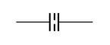
Battery
Orifice
Capacitor
Flow element

494. What is the disadvantage of using chemicals on an oil-spill on the water?
The water gets a white colour, which makes it easy to detect the oil-spill
It is difficult to apply the chemicals if the oil drifts away from the ship's side
It is difficult to apply chemicals if there is any wind
The chemicals make it difficult to remove the oil from the water

495. In a PID controller it is possible to change the setting of the Proportional band (P), the Reset time (I) and the Rate time (D). Please indicate which curve shows the typical response to a step change in input, if the setting of the reset time is too small.
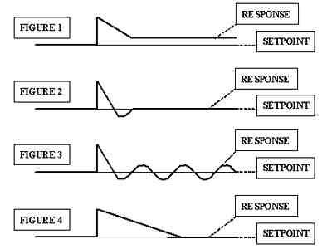
Figure 4.
Figure 2.
Figure 3.
Figure 1.

496. Poster or signs shall be provided on or in the vicinity of survival craft and their launching controls. Which one of the following requirements has to be included?

Give information on survival craft capacity
Give relevant instructions and warnings
Give information on survival craft speed and seaworthiness
Give an overview of location of all lifesaving appliances

497. For a search to be effective it must be:
Inclusive of all personnel.
Conducted by personnel with limited knowledge of the ship's layout.
Centrally controlled.
Organized haphazardly.

498. When considering instrumentation systems,what is the meaning of the expression 'dead-band'?
It will take some time before the controller will react to a change
The controller will enter 'sleep mode'
The controller will is not respond to adjustment of set-point
The controller will not react to a process change in this range

499. Which of these conventions is The International Ship and Port Facility Security (ISPS) Code a part of?

STCW - 95
MARPOL
SOLAS
The Anti Terrorist International Agreement

500. What manoeuvre should be carried out in case of a fire onboard a ship?
Continue on course and speed
Let the ship follow the wind in order to reduce the oxygen supply
Reduce speed and, if possible, keep the fire zone to the leeward of the ship
Keep the stem up against the wind if possible

501. Which of the following temperature sensors normally gives the highest measuring accuracy?
Thermocouple, NiCrNi
Thermistor, NTC
Thermistor, PTC
Resistance sensor, Pt100

502. In tanker operations, there will be some areas and zones where flammable or explosive vapour, gas, or dust may be expected. Such areas are classified as hazardous. What is meant by hazardous area Zone 1?
Flammable mixture is not continuously present, but will be present during normal operations.
Flammable mixture would not normally be present or it would be present for a short period only.
Flammable mixture is not present at all times.
Flammable mixture is continuously present or present for long periods.

503. The most effective way to combat the threat of drug smuggling is to?
"Perform routine, but irregular searches using teams of two or more personnel from the same department."
Organize crew into pairs and conduct weekly searches of the ship.
Perform spontaneous targeted searches using teams of two or more personnel from the same department.
"Combining routine, but irregular searches of the ship with spontaneous targeted searches."

504. What is the function of automatic bus transfer (ABT) switch?
It automatically connects the emergency generator to the emergency switchboard while disconnecting the main switchboard from the emergency switchboard
It automatically connects the emergency generator to the main switchboard while disconnecting the main switchboard from the emergency switchboard
It automatically connects the main generator to the main switchboard while disconnecting the main switchboard from the emergency switchboard
It automatically connects the emergency generator to the main switchboard while disconnecting the main switchboard from the emergency switchboard!

505. *You are on board a cargo ship. The ship is heavily listing to starboard, making impossible the launching of the survival craft stowed on this side. Lifeboats and liferafts are equally distributed on each side of the vessel. What should be the total number of persons that can be accommodated in the remaining survival craft stowed on the port side ? (*) N is the total number of persons that vessel is permitted to carry.
at least 100 % N (lifeboat capacity: 50 % N; liferaft capacity: 50 % N) (*)
at least 150 % N (lifeboat capacity: 100 % N; liferaft capacity: 50 % N) (*)
at least 200 % N (lifeboat capacity: 100 % N; liferaft capacity: 100 % N) (*)
at least 150 % N (lifeboat capacity: 50 % N; liferaft capacity: 100 % N) (*)

506. Give the meaning of the following symbol
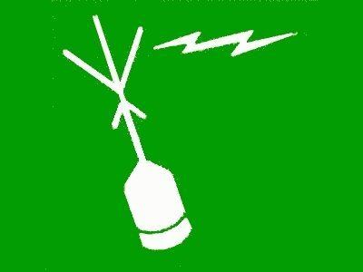
EPIRB
Survival craft portable radio
Survival craft distress pyrotechnic signals
Rocket parachute flares

507. "Which of these precautionary measures can reduce the threat of piracy, if implemented?"
Plan to arrive at port at night.
Turn off all of the ship's lights at night.
Sail at full speed.
Stay at least 15nm away from the shore.

508. What is SOPEP?
A Ship-Owners Permitted Entry Plan
A Shipboard Oil Pollution Exemption Procedure
A Shipboard Oil Pollution Emergency Plan
A Seafarer's Offical Pension and Employment Payment scheme

509. There are many applications in circuit theory where it is important to obtain the maximum possible power that a given source can deliver. This figure consists of a practical voltage source V(g) with internal resistance R(s). What value of resistance R(L) will maximize the power transmission from the source to R(L)?
R(L) = 2 R(s)
R(L) = R(s)
R(L) = R(s) / sqrt (3)
R(L) = 0.5 R(s)

510. What type of protection method does an miniature circuit breaker (MCB) provide?
Adjustable thermal overload and adjustable magnetic short-circuit protection
Fixed thermal overload and fixed magnetic short-circuit protection
Fixed thermal overload and adjustable magnetic short-circuit protection
Adjustable thermal overload and fixed magnetic short-circuit protection

511. Zener barriers are sometimes used to supply power to electronic equipment in hazardous areas. Which statement is correct with regards to power supply for equipment supplied through Zener-barriers?
The - 24V must never be grounded.
The +24V must always be grounded.
The 0-voltage must never be grounded.
The 0-volts line must always be grounded.

512. Who is responsible that regulatory working hours are not exceeded?
The bosun and the second engineer.
The individual person.
The master and department heads.
The safety officer.

513. U-tube manometers are often used to measure differential pressure. Which of the listed pressures are U-tube manometers mostly used for?
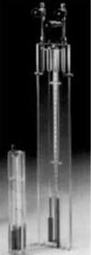
High differential pressures
Low differential pressures
Absolute zero pressure
Cargo pressure

514. A smart transmiter is suspected to be faulty. A few steps need to be taken to assess the functionality of the transmitter. Which of the following is not one of the steps?
Check the precision
Check the calibration
Check the filering
Check the configuration

515. What is the function of a Spectrum Analyzer?
Outputs the voltage wave of the signal
Measures and displays the frequency characteristic
Informs the frequency spectrum of the signal
Measures complex impedance of network at varying frequencies

516. What is the minimum starting requirement of an emergency generator?
2 separate starting devices each with stored energy capable for at least 3 consecutive starts.
1 set of starting device with stored energy capable for at least 3 consecutive starts.
2 separate starting devices each with stored energy capable for at least 4 consecutive starts.
3 separate starting devices each with stored energy capable for at least 3 consecutive starts.

517. Temperatures are often measured by using platinum resistance thermometers. The characteristics shown are all calibration curves for such devices. Which of them is a calibration curve for a P T100 sensor?
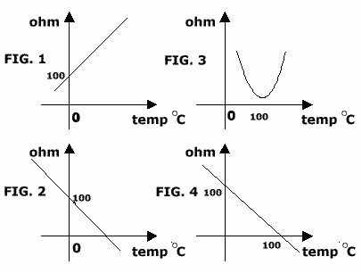
Figure 1
Figure 4
Figure 3
Figure 2

518. When current-carrying conductor is moved in a magnetic field of a motor, as a by-product of motor torque, ______ is produced.
Back e.m.f.
Over-voltage
Excitation
Forward e.m.f.

519. The Declaration of Security:
Addresses the security requirements shared between ships or between a port facility and a ship.
Identifies the security responsibilities of shipboard personnel.
Details a ship's security measures.
States the reporting procedures to government contact points.

520. When a Master takes the leadership in approaching a problem, Must his first action be a decision that will directly solve the problem?
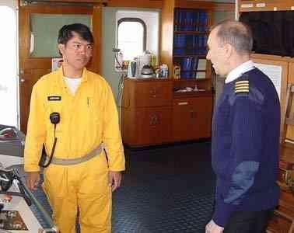
Yes, take full controll. Do not delegate to other officers, to avoid mistake.
No, he should observ the situation, and let the other senior officers solve the situation.
Yes, with his experience, it is most likely that he has the best solution.
Not necessary, he shall use all available resources. He should resist the temptation to step in and do it all by himself

521. It is important to be clear about the performance capability of measuring instruments. How is the accuracy of an instrument expressed?
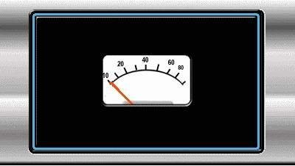
In % of deviation and to least significant digit
In % of full scale and to least significant digit
In % of gauge readings and to least significant digit
In % of range and to least significant digit

522. Where is the Safety Certificates for ships to be kept?
In the Captain's office
In the Owner's office
In the Captain's safe
Posted up in a prominent place onboard the ship

523. In the context of an automated control system, which controller must be tuned first in a cascade control system?
Both at the same time
The secondary controller
Any one of them
The primary controller

524. You are onboard a vessel off the West African coast. You want to dump a mixture of food waste, glass bottles and floating packing materials. Is this allowed? and if so, how far off the coast would you have to be?
This is prohibited
12 nautical miles off the coast
25 nautical miles off the coast
3 nautical miles off the coast

525. When a vessel violates the oil pollution laws, who may be held responsible?
Officers only
Captain only
Any one involved in the operation
Shipowners only

526. What is advantage of pulse-width modulated (PWM) drive?
Does not cause any energy loss during switching
Produces smooth torque, low output harmonic currents
Stabilize fluctuations in voltage in the drive
Stabilized back e.m.f in the drive

527. The purpose of profiling is to?
Get beneath the outer shell of an individual to obtain a more complete picture.
Identify different personality types.
Categorize people based on their nationality and ethnicity.
Make judgements about people based on heir appearance.

528. When considering instrumentation systems, what is meant by static sensitivity?
Corresponding change in signals
Change in input signal divided by change in output signal
Change in output signal divided by change in input signal
Change in input signal times change in output signal

529. MARPOL - Annex V. Disposal of garbage. Your vessel is in the Red Sea (Special Area) and the Chief Cook is requesting to have some food waste burned in the incinerator. Due to problems with incinerator, you decide to have the waste ground in the Grinder (Lump size max. 25 mm) and disposed off into the sea. Is this prohibited, if not, how far from nearest land is this legal?
12 miles
3 miles
25 miles
This is prohibited

530. Which statement about the use of profiling onboard a ship is true?

Profilers need at least half an hour to gather the information they need.
Detection equipment can be used in place of profiling.
Only visitors can be profiled.
A random selection process must be established.

531. Most minor oilspills are caused by:
Human error
Equipment failure
Unforeseeable circumstances
Major casualties

532. What is the minimum test voltage of a 690V switchboard for insulation resistance?
1000V
220V
440V
500V

533. Your vessel has been involved in a collision, which has resulted in a heavy oil leakage. Who should be called to handle pollution claims and damages?

Flag state representative.
The P & I Club's nearest representative.
The Leading Hull Underwriter's nearest
Average Agent. The Classification Society's representative.

534. Below shows a voltage-to-current converter. V+ = 10V, V- = -10V, Re = 5kΩ. When Vi = 0V, Ve = -0.6V. What is Ie?
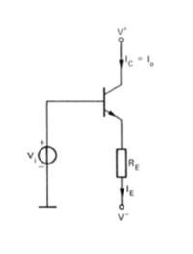
1.88mA
4.25mA
2.25mA
0.127mA

535. What is a Declaration of Security?
A checklist jointly completed by the ship and shore security representatives
A document between the port and the cargo owner stating security
A checklist jointly completed by the Ship Security Officer and the U.S. Coast Guard
A document stating the ship's security level

536. In a PID controller it is possibile to change the setting of the Proportional band (P), the Reset time (I) and the Rate time (D). Please indicate which curve shows the typical response to a step input, if the variables are well adjusted.
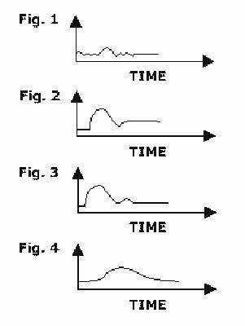
Figure 3.
Figure 1.
Figure 4.
Figure 2.

537. What can lead to "Unlimited responsibility" (OPA-90)
Wilful misconduct and gross negligence
Only gross negligence
Only wilful misconduct
Wilful misconduct, gross negligence and violation of Federal Safety

538. In fresh water tank we are using a pressure transmitter with a range of 0-0.5 bar/4-20mA for level measurement. The transmitter is installed 30 centimetres from the bottom of the tank, and the tank is 5 meters high. What will the output from the transmitter be when the tank is empty?
2,8 mA.
2 mA
4 mA.
5,2 mA.

539. In what kind of measuring equipment might we find a Bourdon-tube?

In a flow metre.
In a pressure transmitter.
In a temperature transmitter.
In an A/D converter.

540. The typical current gain for a common emitter transistor is
One to Tens
One to Thousands
Tens to Hundreds
Hundreds to Thousands

541. What type of level sensing are point sensing probes typically used for in a tank?
High-high or low-low level sensing
Pressure level sensing
Temperature level sensing
Continuous level sensing

542. The pressure inlet to a pressure gauge is varied from zero to full scale and back to zero again. The output (indicating pressure) versus true pressure is shown in the diagram.The non - coincidence(mis - match) of loading and unloading curve is due to internal friction in the instrument. What do we call this phenomenon?
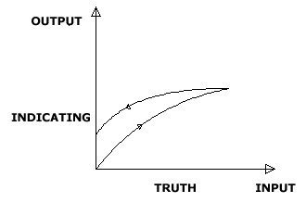
Hysteresis
Resolution
Threshold
Dead band

543. Which international organization is preparing conventions and rules for seafaring nations?
International Marine Association (IMA)
International Maritime Organization (IMO)
International Labor Organization (ILO)
International Ocean Safety Organization (IOSO)

544. With reference to piping and instrumentation diagram (P&ID), what does below symbol represent?
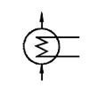
Filament lamp
Heat exchanger
Motor
Anti-condensation heater

545. Following shows the circuit diagram and amplitude transfer characteristics of a particular filter. What is the filter called?
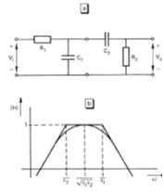
Notch filtert
Bandpass filter
Low pass filter
High pass filter

546. What is the top priority if an incident occurs in US waters (OPA-90)
Protection of the environment
Safety of ship and crew
Any immediate action to prevent loss of time
Prevention of oil pollution

547. What is a salinometer?
Device that measures impurities of water
Device that detects gases in the atmosphere
Device that measures pressure of water
Device that determines air pressure

548. Searches are often triggered by:
News stories of stowaways.
An increase in security level by the Flag State.
Lost baggage.
The receipt of a shipment of damaged stores.

549. Which international convention deals with fire-fighting equipment etc.
Load Line convention
MARPOL
CRISTAL
SOLAS

550. Which of the following locations are lightings not required to be supplied from emergency power for period of 18 hrs?
Service and accommodation alleyways
Emergency fire pump room
Galley
Steering gears

551. A 6-Volt dc relay is to be used with a 12-Volt power supply. The relay requires a current of 0.1 Amp. What is the series resistance required.
120 ohm
80 ohm
60 ohm
480 ohm

552. Who is responsible for ensuring that your ship's security plan meets the requirements of the ISPS Code?
Flag State Administration
Recognized Security Organization
Ship Security Officer
Company Security Officer

553. What is the advantage of proportional–integral–derivative (PID) Control over on-off control?
PID Control has the ability to operate the process with smaller error, thus reducing wear and tear on final control elements
PID Control has fewer control elements compared to on-off control
PID Control has faster response time compared to on-off control
PID Control has faster response time compared to on-off control!

554. What type of protection is Ex e equipment?
Pressurized
Non-sparking
Increased safety
Flameproof

555. Two reference points for pressure exist, absolute zero and atmospheric pressure. What are pressures measured relative to absolute zero called?
Vacuum pressure
Gauge pressure
Pressure drop
Absolute pressure

556. What does the term OIL mean, as used in the Oil Pollution Regulations?
Sludge
Fuel oil
All of the mentioned
Oil refuse

557. Which of these tasks are performed as part of the SSA?
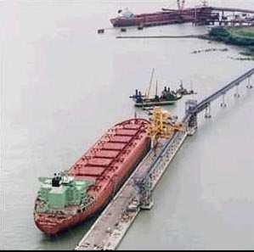
Assess the likelihood and potential consequences of security incidents.
Assign security duties to ship personnel.
Implement measures to address weaknesses in ship security.
Train shipboard personnel in their security duties.

558. Which of the following equipment is responsible for reducing power factor of ship system?
Synchronous motor!
Induction motors
Synchronous motor
Electrical switchboard

559. The Muster List shall show the duties assigned to members of the crew. Which of the following duties shall be included according to present regulations?
Preparation of immersion suits for passengers.
Manning of fire parties assigned to deal with fires.
Special duties assigned with respect to the use of pyrotechnics
Operation of the vessel's propulsion system.

560. Which function is this operational amplifier circuit performing?
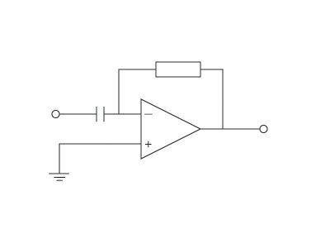
Inverting amplifier
Integrator
Non-inverting amplifier
Differentiator

561. Who is responsible for the vessel's radio station and mandatory radio routines?

The master.
The radio officer.
The owners.
Statutory authorities.

562. Diodes are widely used in rectification, or the conversion of alternating current to direct current. The sinusoidal input voltage V(in) is applied to the circuit shown. Which of the output voltages is correct ?
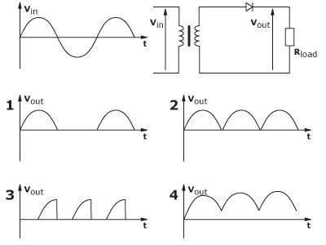
Figure 1
Figure 2
Figure 3
Figure 4

563. Which of the following best describes a feed-forward control system?
The process continually oscillates
Mathematical calculation of the system response
Control of the process inlet side
Easy to obtain a perfect control

564. In a closed loop process control of a valve, oscillations has been found in the output of the controller. What is the probable cause?
Loose connections in the control loop
Control gain is too small
Stiction in the valve
Improperly calibrated valve

565. What does the abbreviation STCW stand for?
The International Shipowners, Transport and Cargo Work Convention
Seafarer's Training and Competence of Watchkeepers
The International Convention of Ship's Trading, Chartering and Waybills
The International Convention on Standards of Training, Certification and Watchkeeping of Seafarers

566. Below figure shows an instrument loop. Which of the following shows the correct instrument flow?
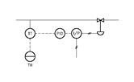
PID sends signal to I/P. I/P then generates a pneumatic signal to operate valve. Valve then sends signal to TT which then sends signal to PID and TR
TT sends signal to both TR and PID. PID then sends processed signal to I/P. I/P generates a pneumatic signal to operate valve
I/P sends pneumatic signal to operate valve. Valve then sends signals to TT which then sends signal to both TR and PID. PID then operates I/P
Valve sends signal to TT. TT then sends signals to both PID and TR. PID processes and then sends signal to I/P

567. What type of logic gate IC is shown in the below picture?
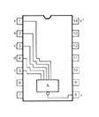
5 split duplicate NAND logic gate
5 split duplicate AND logic gate
5 Input AND logic gate
5 Input NAND logic gate

568. Information about your ship's security arrangements and procedures is stored electronically. Which of these measures will help safeguard it from potential threats?
Work history verification
Protective markings
Encoded email messages
Passwords

569. The instrument most widely used for testing of semiconductor diodes is
Oscilloscope
Multi - meter
Ammeter
Voltmeter

570. In a closed loop system, how is the controller output determined by?
It is determined by difference between the process variable and set point
It is determined by the process variable and noise
It is determined by the set point only
It is determined by the final output

571. In case of a pollution in US waters, who shall notify the cleaning up contractor (OPA-90)
The Master
The shipowner
Emergency response team
Qualified Individual

572. Which of the following tripping methods does not provide overcurrent protection?
Preferential trip
Electronic trip
Electromagnetic trip
Thermal trip

573. Which of the following is an application of a thermoelectric sensor?
Thermocouple
Piezoelectric sensor
Proximity sensor
Barometer

574. When the cable length exceeds approx. 10 meters we normally have to, in case of a Pt 100, in some way compensate for the cable resistance. Do we also have to do this if we choose to use a T802 temperature sensor?
Not applicable
Yes
No
Depends on temperature to be measured.

575. How frequently should reports from protection and environmental work be sent to shore based management?

Every three years.
Not mandatory to send reports.
Annually.
Biannually.

576. The circuit symbol is a driver for a solenoid (coil) of a solenoid valve S. What is the purpose of the diode IN 4002 connected in parallel to the solenoid S?
Blocking for +15V to the emitter of the transistor 2N5194 to stop it from overheating.
Making voltage drop of approximate 0.5V between the operational amplifier and the transistor 2N5194 to assist transistor biasing.
Open circuit for current flow between the operational amplifier and the transistor 2N5194
Allowing stored energy in solenoid to dissipate as freewheel current and therefore prevent damage to transistor from inductive switching voltage.

577. Which operating voltage level requires a mandatory work permit for maintenance purpose?
Greater than 1kV
Greater than 440V
Greater than 690V
Greater than 3.3kV

578. 220V is applied to a transformer. The primary side has full turns while the secondary side has half the turns. There is a resistive load of 10 ohms. What is the primary side current?
88A
2.75A
22A
5.5A

579. Which of the following is not a resistive sensor?
Load resistor
Thermistor
Photoresistor
Strain gauge

580. A motor is found to be overheated. A maintenance check was done and there was no overload. What is remedy to resolve the overheating?
Ventilation passages may be blocked and should be blown out with compressed air
Check state of brushes and slip rings.
Replace with new cables of sufficient current carrying capacity
Replace with new rotor

581. What is 1 byte?
1024 bits
8 bits
32 bits
16 bits

582. Which of the following is not a function of a control valve?
Regulate rate
Measure flow
Interrupt flow
Divert flow

583. The diagram shows a calibration curve for a pressure gauge. What is an alternative name for the slope of the characteristic?
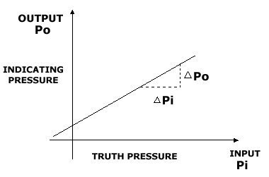
Off-set
Repeatability
Sensitivity
Hysteresis

584. Eavesdropping and phone taps are examples of which threat to information security?
Espionage
Terrorism
Subversion
Sabotage

585. Which of the following is not an advantage of using a softstarter?
It provides good soft starting and stopping with torque control
It eliminates occurrence of overvoltage during operation
It avoids nuisance tripping of generators when starting large motors
It eliminates peak demand charges when starting large motors

586. When considering instrumentation systems , what is the meaning of the term "Span" of a transducer.
The length between the mounting flanges
The difference between maximum and minimum measurement that gives a standard output signal
The maximum output signal when you have a minimum process value
Type of standard output signal according to ISO and EN standards

587. A valve which is already tuned with controller is found to be improperly calibrated. What is the rectification that needs to be taken in order for valve to function properly with controller?
Use controller to recalibrate the valve
Recalibrate the valve only
Recalibrate the valve and retune the control loop
Retune the controller only

588. In US waters "Oil Pollution Act of 1990" was activated in August 1993. What is the main issue for the introduction of the act?
To prevent oil spills in US waters?
To encourage owners to build double hull vessels for trading US waters?
To improve safety measures onboard?
To enforce owners to use equipment of higher standards that those of today?

589. Onboard training should be organised in such a way that:
It is an integral part of the overall training plan and does not contravene with the rest hours of the crew
none of the above
It does not contravene with the rest hours of the crew and each crew member is trained individually
Each crew member is trained individually

590. In relation to exhaust gas measurement with a thermocouple, use of an amplifier which gives a mA-signal out is preferred. Why is this done?
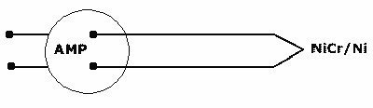
To stabilize the signal andmake it easier to measure at the receiver.
The output signal from a thermocouple is at mV level,and can not be transferred over any long distance without loss of signal, giving a poor accuracy and poor noise immunity.
This depends on the length of the compensation-cable.
The signal out from the thermocouple is also mA, but have to be amplified in order to give a good signal to the alarm system.

591. The line voltage of a three phase system is 440V. What is the phase voltage?
110V
147V
254V
311V

592. The steps of the embarkation ladder used must be spaced apart by a distance of:
300 mm
200 mm
equally spaced, not less than 200 mm or more than 280 mm
Equally spaced and not less than 300 mm or more than 380 mm

593. Why is input aliasing important in digital process control?
It reduces lag and deadtime in digital process control
It increases accuracy and precision of process measurement
It reduces noise dampening in digital process control
If frequency of signal sampling is not fast enough, digital representation of original signal will not be accurate

594. What are the main steps to convert an analogue signal to digital signal?
Amplification, filtering, modulation, demodulation, A to D conversion
Amplification, inversing, modulation, demodulation, A to D conversion
Amplification, filtering, demultiplexing, A to D conversion
Amplification, multiplexing, demodulation, A to D conversion

595. Which information should be included in your search plan?
Personnel to be involved in the search.
Areas to be searched and personnel to be involved in the search.
Areas to be searched.
Known hiding spots to be searched.

596. Which alternative is correct for measuring current through the load L?
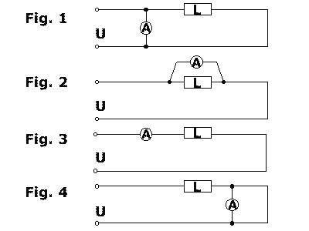
Figure 4.
Figure 2.
Figure 3.
Figure 1.

597. Which personnel must undergo familiarization training on board?
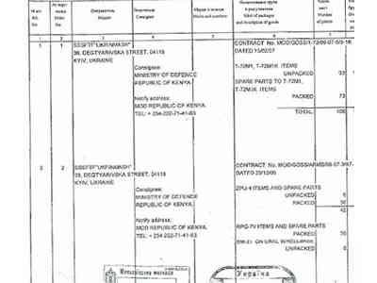
Only the deck officers
Only the ratings
Only catering staff
Everyone

598. What should you do with the ashes from your vessels incinerator if you have incinerated garbage containing plastics?
Discharge at sea providing you are more than 12 miles offshore
Discharge at sea providing you are more than 25 miles offshore
MARPOL demands discharge to a shore facility, regardless of content
Discharge at sea providing you are not in any river or estuary

599. In process control some situations lead to a need for dynamic amplifying. What is meant by dynamic amplifying?
Amplitude of output signal divided by amplitude of input signal
Amplitude of input signal divided by amplitude of output signal
Corresponding change in signals
Variable amplifying

600. Why is it important to have good a relationship between the crew on board a vessel?
It will prevent accidents from happening
Crew comes to know each others problems
It encourages crew to extend their contract
It leads to better work performance and positive atmosphere among the crew

601. Control triangular or ramp voltage (using Schmitt-trigger switching) can be produced by alternating charging and charging:
An inductor with constant current
A capacitor with a constant current
A capacitor with sinusoidal current
An inductor with sinusoidal current

602. Which of the following requirements regarding on board stability data corresponds to present regulations? (NSCL 4/12.1)
Stability data produced by stability calculation instruments.
A calculation example showing use of "GM" limitation curves.
Drawings and caculations documenting the stability of the ship, both in intact and all possible damage condition.
A calculation example showing the use of "KG" limitation curves.

603. This circuit shows a transformer with two windings, N (1) = 2000 and N (2) = 1000 turns, on a common magnetic circuit. Assume that there are no energy losses in the transformer itself. Calculate the output voltage V (2) when the input voltage is V (1) = 100 Volt.
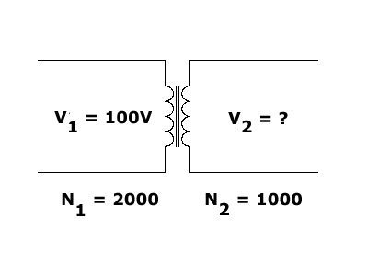
V (2) = 10 V
V (2) = 400 V
V (2) = 50 V
V (2) = 200 V

604. The OPA-90 notification requirement is:
Notify as soon as you have knowledge of a spill exceeding 10 gallons of oil
Notify only if you mean that own vessel might be tracked and charged
Notify as soon as you have knowledge of any spill, or threat of a spill
Notify only if you mean that own vessel might be responsible

605. Which of the following is an application of a piezoelectric sensor?
Thermocouple
Proximity sensor
Accelerometer
Tachometer

606. Flow irregularities in pipes are not caused by:
Restrictive valve
Elbow pipe
Throttling Valve
Straight pipe

607. Use Kirchoff's current law and Ohm's law to calculate the value of the current I for this circuit.
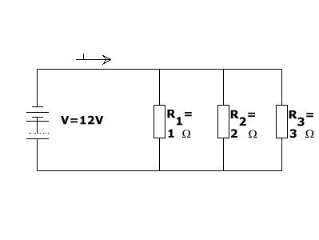
48A
22A
72A
2A

608. This is a parallel L-C circuit with a curve showing frequency- impedance characteristics. Which of the formulae A to D gives the resonant frequency fo?
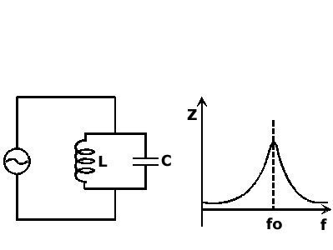
fo = 1 / (Pi*sqrt (1 - LC))
fo = 1 / (sqrt (1 - LC))
fo = Pi*sqrt (L/C) / C
fo = 1 / (2*Pi* sqrt (L*C))

609. The circuit consists of two inductors, L(1) = 6 H and L(2) = 12 H, in series. Calculate the equivalent total inductance.
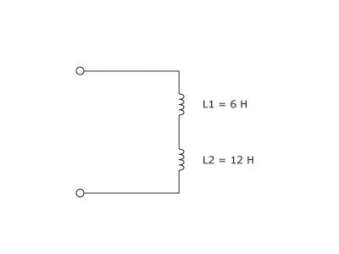
L(S) = 1,5 H
L(S) = 0.5 H
L(S) = 4H
L(S) = 18H

610. From the list below, which is among the recommended actions for a vessel to take, on entering an area known for pirate activity?
To confine all ship's personnel to one room onboard
To turn off all lights
To transit at night time only
To transit with maximum safe speed

611. When moving into an Emission Control Area for Sulphur, which of these is most important?

That the change-over to low Sulphur fuel was started before entry into the ECA
That low Sulphur fuel is actually being burned before entry into the ECA
That the change-over to low Sulphur fuel is complete before arrival in port
That the change-over to low Sulphur fuel is started before arrival in port

612. Which of the following is not a mode of a closed loop control?
On-off
Manual
PID
Modulation

613. Given a power system having values of apparent and reactive power at 500kVA and 300kVAr respectively, what is the power factor valued at?
1.6
1.0
0.8
0.6

614. A nameplate for an equipment used in Hazardous Area has the following description: Ex d IIB T4 What does T4 stand for?
Gas group of equipment
Ignition temperature of equipment
Equipment with non-sparking protection
Maximum surface temperature class of equipment

615. A controller was idle for 10 seconds. The controller output change at the 25th second. The process variable started to change at the 50th second. What is the dead time?
85 seconds
25 seconds
35 seconds
15 seconds

616. In a closed loop control system, how is the controller output determined by?
It is determined by the process variable and noise
It is determined by the final output
It is determined by the set point only
It is determined by difference between the process variable and set point

617. What is the result of an "unusually large metacentric height"?
The vessel will roll violently
The vessel will roll slowly or be unstable
The vessel's tweendeck heights is too high
The vessel will have a great bending moment

618. What is usually the effect on G when the ship is damaged below the waterline, with water ingress?
It first rises then lowers
It lowers
It rises
It is unchanged

619. As far as possible, all engines in lifeboats and rescue boats should be run
for a total period of not less than 5 minutes every month
for a total period of not less than 3 minutes every week
for a total period of not less than 10 minutes every week
for a total period of not less than 3 minutes every month

620. A dynamic test of the winch brake with a proof load equal to 1.1 times the weight of the survival craft or rescue boat and its full complement of persons and equipment should be carried out
every three years
every ten years
every year
every five years

621. A contractor is hired to install new navigation equipment onboard your ship while it's berthed. For a period of time he's left unsupervised and photographs schematics of the ship that he finds rolled up and stored in the corner of a nearby office. Later, from home, he hacks into the network and prints off information about the ship's security procedures. Which of these information security measures would have prevented his unauthorized access?
Firewall, protective markings, vetting and a secure network.
Secure area, passwords, a firewall and protective markings.
Secure area, passwords, a firewall and a secure network.
Protective markings, reference checks, and passwords.

622. Which of the connections you are shown, is the dedicated shore connection (MARPOL-connection) for discharging of sewage ?
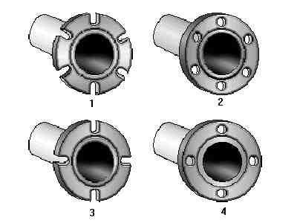
2
4
1
3

623. What is the valve status as shown below?
Valve fails in the fully open position
Valve is overfilled with fuel oil
Valve is filled with fuel oil
Fuel oil valve

